Table of Contents

CHAPTER 1: INTRODUCTION 8

1.1 Topic of the System 9

1.2 Purpose of the System 9

1.3 Target User 9

Student: 9

Administrator: 10

1.4 Topic Background 10

1.5 Problem Context 10

1.6 Rationale 11

Tangible Benefits 12

Intangible Benefits 12

1.7 Scope and Objectives of the system 12

Project Objective 12

Academic Objective 13

Scope of the System 13

1.8 Functionalities of the System 14

Core Functionality 14

Special Functionality 15

Enhanced Functionality 15

1.9 Feasibility Study 15

Technical Feasibility 16

1.10 Schedule Feasibility 17

Operational Feasibility 17

1.11 Economic Feasibility 17

1.12 Ethics Commitment 18

CHAPTER 2: PROBLEM DESCRIPTION 19

2.1 Problem 19

2.2 Problem Description and Solution 19

CHAPTER 3: LITERATURE REVIEW 20

3.1 Literature Review 20

Domain 20

Barcode 20

Optical Character Recognition 21

RFID: 21

3.2 An RFID system is an integrated collection of components that implement an RFID solution. 22

Fundamentals of Smart Card Technology 22

Smart Card Technologies 22

3.3 CONCLUSION: 23

CHAPTER 4: RESEARCH MEETHODS 24

4.1 Primary Research 24

4.2 Questionnaires 24

Few Advantages of Questionnaire 24

Why Questionnaires 24

4.2.1 Questionnaire Process Explanation: 25

4.2.2 Questionnaire 25

4.3 Interview 31

Why Interview? 32

Interview Questions 32

4.4 Academic Research 33

4.4.1 Why Spiral Model? 34

2. Analysis 36

4. Development 36

CHAPTER 5: ANALYSIS 37

5.1 Questionnaire 37

5.1.1 Analysis of Questionnaire 37

5.1.2 Overall Conclusion of Questionnaire 37

5.2 Interview 38

5.2.1 Analysis of Interview 38

5.2.2 Overall conclusion of Interview 38

CHAPTER 6: SYSTEM DESIGN 39

6.1 Introduction 39

6.2 Use Case Diagrams 40

6.2.1 Use Case for Whole System (UC-01) 40

6.2.2 Use Case for Admin Module (UC-02) 42

6.2.3 Use Case of Library Module (UC-03) 44

6.2.4 Use Case for Student Module (UC-04) 45

6.2.5 Use Case for Cafe Module (UC-05) 46

6.2.6 Use Case for Parking Module (UC-06) 47

6.2.7 Use Case for Sign In (UC-07) 48

6.2.8 Use Case for Database Access Control (UC-8) 49

6.3 Activity Diagram of Whole System 50

6.4 Sequence Diagram of View Transaction 51

6.4.1 Sequence Diagram of Verify user 52

6.4.2 Sequence Diagram of Fund Transfer 53

6.6 CLASS DIAGRAMS 54

6.5 Entity Relationship Diagram 56

CHAPTER 7: IMPLEMENTATION 57

7.1 Introduction 57

7.2 Tools Used for Modelling and Implementation 57

7.3 Hardware Requirements: 58

7.4 Implementation Plan 58

7.5 Implementation Approach Followed 59

7.6 PROBLEMS OCCURRED DURING REGISTARATION MODULE IMPLEMENTATION 60

7.6.1 SOLUTION FOR ENCOUNTERED PROBLEM 60

7.7 Implementation of Modules 61

7.7.1 Complex Feature: 62

7.7.2 Logically Complex Feature 64

7.7.3 Complex Feature of language or coding used 65

7.7.4 Technical Quality UI 66

7.4.5 Functional Quality 69

7.5 Performance 71

7.6 User Interface 71

7.7 Comments 71

7.8 User Manual 72

7.8.1 Admin Module 72

7.8.2 Student Module 74

7.8.3 Library Module 76

7.8.4 Cafe Module 79

7.8.5 Parking Module 81

CHAPTER 8: TESTING 84

8.1 Introduction 84

8.2 Testing Approach 84

8.3 Types of Testing 84

8.4 Pass/Fail Criteria 86

8.5 Test Cases 86

8.5.2 Student Module 89

8.5.3 Admin Module 90

8.5.4 Library Module 92

8.5.5 Parking Module 94

8.5.6 Cafe Module 97

8.6 White Box testing 100

8.6.1 Justification for white box testing 100

8.7 Integration Testing 100

8.7.1 Technique Used for Integration Testing 101

8.7.2 Justification of Integration Testing 101

8.7.3 Registration + Login 101

8.7.4 Check-In + Check-Out 102

8.8 System Testing 102

8.8.1 Justification for System Testing 102

8.9 Compatibility Testing 105

8.9.1 Justification for Compatibility Testing 105

8.10 GUI Testing 107

8.10.1 Justification for GUI Testing 107

8.11 Usability Testing 108

8.11.1 Justification for usability Testing 108

8.11.2 Usability Testing on the basis of five factors: 110

8.12 User Acceptance Testing 110

8.12.1 User Acceptance Testing 110

8.13 Documentation Testing 111

8.14 Conclusion 112

CHAPTER 9: CRITICAL EVALUATION 113

9.1 Critical Evaluation 113

9.2 Benefits of the System to target User 113

Tangible Benefits 113

Intangible Benefits 114

9.3 Degree of Success 114

9.4 Research and Analysis 114

9.5 Critical Appraisal 115

CHAPTER 10: CONCLUSION 116

10.1 Success Criteria 116

10.2 Limitations and errors in the developed system: 116

10.3 What would have been done if given time to redo the project? 116

10.4 Future Enhancements 117

10.5 Learning Experience Gathered 117

REFERENCES 119

Books: 119

Websites: 119

**Table of Figure**

Figure 1 Use case Diagram for whole system (UC-01) 40

Figure 2 Use Case for Admin Module (UC-02) 42

Figure 3 Use Case for Library Module (UC-03) 44

Figure 4 Use Case for Student Module (UC-04) 45

Figure 5 Use Case for Cafe Module (UC-05) 46

Figure 6 Use Case for Parking Module (UC-06) 47

Figure 7 Use Case for Sign In (UC-07) 48

Figure 8 Use Case Description of Database Access Control 49

Figure 9 Activity Diagram of Whole System 50

Figure 10 Sequence Diagram of View Transaction 51

Figure 11 Sequence Diagram of Verify user 52

Figure 12 Sequence Diagram of Verify user 53

Figure 13 Class Diagram1 54

Figure 14 Class Diagram2 54

Figure 15 Class Diagram3 55

Figure 16 Entity Relationship Diagram 56

Figure 17 Flow Chart of Login 62

Figure 18 RFID Mechanism 62

Figure 19 Comments 71

Figure 20 Types of Testing 84

**Table of table**

Table 1 Use Case Specification for whole system (UC-01) 41

Table 2 Use Case Specification for Admin Module (UC-02) 43

Table 3 Use Case Description of Sign In 48

Table 4 Implementation Tools 57

Table 5 Hardware Tools 58

Table 6 Types of Testing Explained Briefly 85

Table 7 Home Test 86

Table 8 Registration Test 88

Table 9 Login Test Case 88

Table 10 View Profile Test Case 89

Table 11 View Transaction Test Case 89

Table 12 Fund Transfer Test Case 90

Table 13 User List Test Case 90

Table 14 View Graph Test Case 91

Table 15 Recharge Card Test Case 91

Table 16 LogOut Test Case 92

Table 17 Book Test Case 92

Table 18 View Transaction Test Case 93

Table 19 Verify User Test Case 93

Table 20 Change Password Test Case 94

Table 21 Logout Test Case 94

Table 22 Vehicle Test Case 95

Table 23 Check-in Test Case 95

Table 24 Check-Out Test Case 96

Table 25 View Transaction Test Case 96

Table 26 Change Password Test Case 97

Table 27 Log Out Test Case 97

Table 28 Items Test Case 98

Table 29 Generate Bill Test Case 98

Table 30 View Transaction Test Case 99

Table 31 Verify User Test Case 99

Table 32 Change Password Test Case 99

Table 33 Log Out Test Case 100

Table 34 Registration + Login 101

Table 35 Check-In + Check-Out 102

Table 36 System Testing 105

Table 37 Compatibility Testing 107

Table 38 GUI Testing 108

Table 39 Questionnaire for Usability Testing 109

Table 40 Usability Test 110

Table 41 User Acceptance Form 111

Table 42 Documentation Testing 112

Table 43 System Requirement evaluation 114

Table 44 Research and Analysis evaluation 114

|  |
| --- |
| CHAPTER 1: INTRODUCTION |

Student smart card is a project which aims towards building a system/application which would allow students to have multiple benefits using a single smart card issued to them.

* The project involves a card which contains a barcode which is nothing but a unique card that is assigned to the student. This card can be refilled as and when required by the student with the help of admin.
* This card is useful for the student in places like cafeteria, parking and stationary shops. When the card is inserted or scanned using the barcode scanner, the unique id stored is scanned and accordingly cash is deducted.
* This card can be used to submit important documents that will be needed by the student for any of its work. This is done by scanning the unique id stored in the card which is the sent to the server where the student's document is stored and is directly sent from the server wherever needed.

Thus, the user doesn't have to carry its documents always. The student can use this card in library to pay fine and the amount of fine will be calculated depending on the information stored which is retrieved with the help of an ID stored in the card.

Same way in case of stationary shop where the cash amount is deducted from the student's account and same way in case of canteen. Thus, the student just needs to carry the portable card. Thus, this card is very beneficial for a student and makes many of its work easy.

## 1.1 Topic of the System

The primary goal of this project is towards building a system/application which would allow students to have multiple benefits using a single smart card issued to them. It can be used for attendance, college entry, cafeteria, parking etc which will make work easier for each and every single person.

## 1.2 Purpose of the System

In this emerging world of technology, there is a need of doing things, quickly and at one place, nobody is ready to get the same kind of services from different- different places, also they need services in very low cost and in very less time and the services must be easily accessible and the proposed system will fulfil this need by providing a single smart card for multiple activities such as marking attendance, college entry, payment in cafeteria, parking payment, stationary shops so the user can fulfil the purpose of:

* This card can be used for attendance using the barcode system in every classroom.
* A college gate entry passes for each and every student.
* Paying cash for food items purchased in cafeteria.
* Stationary shop bills are paid with help of this card.
* Payment for Parking.
* Used for carrying important document so that student’s need not to carry hardcopy of the same.
* Student can view their last five transactions.

## 1.3 Target User

This system’s main target audience is the major education institutes for professional studies and High end tuition centers which help students for their preparation. Now a day every major educational institutes are in reform and they want to adapt with the todays world and provide a competitive result in return. However, for classification purposes the developer has classified the audience or the target user for the system.

Student: -Students are the prime user for the system. The students are one whose data collected in form of data warehouses. The system main intended purpose is to provide a smart card which will be used for college entry pass, attendance marking, cafeteria, parking etc. The card is being scanned to deduct cash amount from the user's account or get the student's important documents or mark the attendance.

Administrator: -The main work for the administrator is to refill the balance of the student’s card. The admin can also access the other information of students such as Student’s payment related information, Student’s attendance related information. The admin is responsible for maintaining the accounts of the students holding the card.

## 1.4 Topic Background

This project is developed to ease the work of students. The project involves a card which contains a barcode which is nothing but a unique card that is assigned to the student. This card can be refilled as and when required by the student with the help of admin. This card is useful for the student in places like library, canteen and stationary shops. When the card is inserted the unique id stored is scanned and accordingly cash is deducted from the student's account. This card can be used to submit important documents that will be needed by the student for any of its work. This is done by scanning the unique id stored in the card which is the sent to the server where the student's document is stored and is directly sent from the server wherever needed. Thus, the user doesn't have to carry its documents always. The student can use this card in library to pay fine and the amount of fine will be calculated depending on the information stored which is retrieved with the help of an ID stored in the card. Same way in case of stationary shop where the cash amount is deducted from the student's account and same way in case of canteen. Thus, the student just needs to carry the portable card. Thus, this card is very beneficial for a student and makes many of its work easy.

## 1.5 Problem Context

The project inevitably experienced problems. This had been expected given the complexity of the new technology and in view of the major changes to existing systems and procedures. A number of suppliers underestimated the task of meeting the acceptance test criteria and as a result some devices were not delivered on time. Some returning students who had registered on previous occasions ignored new instructions for completion of card application forms and consequently commenced a new session without a card necessary to enable them to continue to use the library and other essential facilities. Most of these problems were resolved by the end of the second week of the first term. A number of devices suffered from operational problems as a result of the build-up of accumulated dust and dirt on the embedded chip. Our learning curve has been steep and continues.

The pilot project indicated a number of student types for whom normal, standard enrolment procedures did not apply. This category therefore arrived at the University expecting to take immediate advantage of facilities available but was unable to do so until completing the card issuing procedure. Changes were necessary to procedures in subsequent years in order to address such problems.

College is also facing major problems by foreign and local students in using the library and labs. In the library, there have been numerous cases where books are being borrowed and have not been returned by the students. Besides, according to the library rules, each student can only borrow two books at a time and a fine would be imposed for books that are returned late. This is often overlooked as all these rules are applied manually. As for lab usage, there are cases where students misuse the lab by using the Internet for hours. Therefore, other students are unable to utilize the lab to complete their assignments. In addition, the students have been misusing the printing facilities in printing contents that are not related to their studies. This incurs higher expenses to college in purchasing printing papers and replacing the printer cartridge.

Based on the above-mentioned problems, Institute has decided to implement a smart card system that would help to reduce their problems and eventually eliminate them. The smart card system is crucial for the institute to closely monitor their students’ attendance to ensure that the students are attending all their classes. The institute would take relevant actions if the students are missing their classes prior being caught by the immigration for working illegally.

## 1.6 Rationale

This application provides benefits in many ways, like it allows users to get issued book from library, payment can be done in cafe, parking, library etc.

The system to be implemented could bring about significant tangible and intangible benefits. Given below is a list of tangible and intangible benefits expected from the system:

### Tangible Benefits

* The Student doesn't have to carry its document always; all it needs to carry is the portable card.
* There is no need for the student to carry cash. It just needs to refill its card via admin.
* The system helps the users to easily find out defaulters.
* Keeps data privacy
* Keeps the keyword privacy
* Make the search easier
* It saves time, cost, efforts and institute resources.

### Intangible Benefits

* Saves time and efforts.
* Every module requires a barcode reader to access the system.
* Faster and accurate results.
* This Application will provide a better and enhancing teaching experience to the students as well an interactive session for the Users. Also the application will give a better output and will use the efficiency of the User.

## 1.7 Scope and Objectives of the system

**Objectives of the System**

### Project Objective

The project objective of this system is to provide premium services to its users, in low cost and in less time with high availability and some of these premium services are mentioned below-

* The smart card can be used for issuing book from library using the barcode reader in library.
* Student can transfer fund into others account.
* Paying cash for food items purchased in cafeteria.
* Stationary shop bills are paid with help of this card.
* Payment for Parking.
* Used for carrying important document so that student’s need not to carry hardcopy of the same.
* Student can view their last five transactions.

### Academic Objective

* To learn advanced programming techniques like .Net Framework, background services, database etc.
* Project management concepts like methodologies, scheduling, time and cost estimation, work breakdown techniques and tools etc.
* Working with client-server communication.
* To implement the knowledge gained in Objectives to develop such a system which leads to goal mentioned above.
* To make efforts to ensure that the system being developed will fulfill all the tangible and intangible benefits mentioned in the previous section.

### Scope of the System

With the increase in the application development (due to the implementation of the smart card standards) and reducing cost in technology, plans for the card’s usage have increased. However, majority of the applications are either being piloted or implemented in Europe, but are not widely accepted in the U.S. just yet.

The future of Smart Cards is looking bright. The many existing and potential benefits smart card has to offer both the public and the private sectors of the industry raise the interests of many large corporations such as school and college. Compared to the conventional magnetic stripe cards, smart cards offer increase security, convenience, and economic advantages. Reducing fraud, reducing time to complete redundant paperwork, and having the potential to have one card to access diverse networks and applications are just some of such examples. The discussion for the future of the smart card across the global industries can be divided into public and private sectors.

The modules for the proposed system have been listed below:

**Admin Module**

In this module, admin can add users, view users, recharge account of student.

**Student User Module**

In this module, user can view balance, change password, view transaction history, and fund transfer to other student can be done here in this module.

**Cafe User Module**

In this module, user can add items, view items, generate bill, change password, view transactions, verify users.

**Library User Module**

In this module, user can add books, view books, issue book, return book, change password, view transactions, verify users.

**Parking User Module**

In this module, user can add student vehicles, view vehicle details, check-in, check-out, change password, view transactions, verify users.

## 1.8 Functionalities of the System

The feature and functionalities of the application includes:

### Core Functionality

* **Admin Module**

The admin can login and can refill the balance of the student’s card.  
The admin can also access the other information of students:

* Student’s card related information.
* Users graph related information.
* All type of Users related information.
* Other common admin features
* **Student Module**

The Student can login and view balance and last five transactions which will help him to be aware of his card balance and accordingly refill it whenever required.

Student can transfer funds into others account.

* **Account maintenance**

The admin is responsible for maintaining the accounts of the students holding the card.

* **ID scanning**

The card is being scanned to deduct cash amount from the user's account or get the student's important documents.

### Special Functionality

* **Payment in cafe**

This ID on the card can be scanned to pay for the food items purchased in cafeteria.

* **Payment for parking**

The card can also be used to pay for parking.

* **Document Carrier**

The card's unique ID can be used to retrieve the important documents (results,) of the student stored on the server. Thus, the student doesn’t have to carry the hardcopy of the documents always.

### Enhanced Functionality

* **Check-In**

Students just have to scan their cards using barcode reader and the system notes down their ID and they can check-in to Parking.

* **Check-Out**

Students just have to scan their cards using barcode reader and the system notes down their ID and they can check-out from Parking.

## 1.9 Feasibility Study

It can be defined as an investigation into a project or proposed plan in order to determine whether and how the proposed project can successfully and profitably. It is performed in order to measure whether the project is feasible. Developer of the proposed system carefully conducted feasibility by keeping in mind with considerations of two important factors time and resource. Developer of the proposed system has to go through several stages for the successful accomplishment of the project and here feasibility study becomes important, in order to make sure that the software is built according to its specification. Conducting feasibility study is considered as a good business practice. There are different types of feasibility study but the developer divided the feasibility study in four major types. They are as follows:-

* Technical Feasibility
* Schedule Feasibility
* Operational Feasibility
* Economic Feasibility

Developer of the proposed system carefully carried out research and study on all these types in order to determine whether it is feasible to carry out the development of the proposed system.”

In short and simple words, a feasibility study is done to check whether the system which is going to be developed is feasible technically, operationally, economically and whether it is feasible over a period of scaled time.

### Technical Feasibility

Developer of the proposed system carried out technical feasibility in order to determine the requirements of technologies for the current system. It is very much essential and necessary for the developer to determine that the current technological resources are sufficient to develop the proposed system or there is need to upgrade the technological resource. There is a need carefully conduct this study because it is considered as one of the most important study in all aspects. Developer needs to answer few things in order to conduct technical feasibility study. These are: -

* Is proposed technology or solution practical?
* What kind of technology will developer need?

After answering all of the above questions it is conducted and concluded feasibility study.

**Hardware and Software Requirements:**

Below, the list of hardware and software are shown which are required during the development of system.

**HARDWARE CONFIGURATION**

PROCESSOR -Pentium 4 and above

RAM SIZE -2GB

HARD DISK DRIVE-50GB

CD ROM DRIVE -52X

KEYBOARD -108 keys

MONITOR -SVGA 15 inch

MOUSE -PS/2

**SOFTWARE CONFIGURATION**

FRONT END -ASP.NET

BACK END -SQLServer 2008

OPERATING SYSTEM –WINDOWS 10

SCRIPT LANGUAGE -C#

BROWSER -Google Chrome, Firefox etc

## 1.10 Schedule Feasibility

This feasibility is related is used to determine the time factor related to current system. It is very much necessary for the developer to define deadlines for the project. Only defining is not important but also there is a need to accomplish the work on due time. There is a need to build a System/ Solution in time which is useful. Also, there is need to answer few questions during and after the development in order to acquire accuracy and usefulness.

* What are the consequences of delay?
* Any Constraints on schedule?
* Can these constraints be met?

As developer knows the fact that most of the project fails due to delay in project deadline. Answering above mentioned questions will help the developer to eradicate problems in schedule feasibility. Developer has maintained a Gantt chart for defining task with deadline dates. This will help developer to evaluate project development process.”

### Operational Feasibility

Developer of the proposed system carried out operational feasibility study to make sure that if the proposed system is developed, will it be used. It is very much necessary to conduct because there is a need to determine that the proposed system which is going to be developed can satisfy and meet user requirements and expectations. It is very much necessary to analyze user requirement and to what level the proposed will meet the expectations. Developer will perform a competitive analysis of the available systems in the market. This will help in getting a closer view to the features of similar systems available in market and to focus on features which are going to be supplied with the proposed system. After conducting competitive and comparative analysis developer concluded that it is feasible to build the proposed system. Several testing’s will be performed for ensuring quality of the proposed system.”

## 1.11 Economic Feasibility

It is the most important feasibility study used to evaluate the effectiveness of the candidate system i.e. proposed system. The effectiveness should be in term of Cost effectiveness and Benefits (Tangible/ Intangible). It is very important to determine tangible and intangible benefits associated with the proposed system, since the degree of success of proposed system depends a lot upon this factor. Identifying benefits associated with the proposed system has a greater impact on the development and usefulness of the desired output. So, developer identified tangible and intangible benefits of the proposed system which is discussed.

## 1.12 Ethics Commitment

It ensures that the project will not be going to harm the society or anyone in anyways. It contains issues like no animal harm & not copying of data without prior permission of the author etc. and to ensure that the developer has filled up an ethical form and it will be provided in documentation. It also ensures no information of user will be leaked outside the system.

|  |
| --- |
| CHAPTER 2: PROBLEM DESCRIPTION |

## 2.1 Problem

The traditional method of monitoring has some drawbacks. This method obviously not efficient as it wastes the user’s energy and quite slow in term of completion. For example, a class that uses attendance sheet method requires the students to pass the sheet to each other to sign up the monitor. If there is a large amount of students, it will take time in order to complete the monitoring. Besides that, there is possibility that some students might miss their turn to sign the attendance as they did not receive the attendance sheet. It is same goes to the “punch card” system. The Workers i.e. employees has to queue up for a long time as each employee need to punch the card and then put it in the slot provided according to their names. In summary, both system give drawback in term of performance.

Less Availability: The other smart card applications present in market require bar code scanner to get connected, so if a user doesn’t have such things which is not having the capability to connect then they cannot get any information from the application so they did lack in availability.

Storing documents: The useful and necessary documents are carried by user for their work. So, there is chance of misplace of important documents.

## 2.2 Problem Description and Solution

The following problems are there in the current system:

* The organizations data is not centralized: For this we are centralizing the system over the server so that the data can be accessed from anywhere.
* The Database management: It becomes easier to manage the data over the server with the help of the system. The user does not have to worry about the data management procedures.
* User Authentication: For user Authentication, we have the process of login into the system so only registered user can access the data.
* Data Privacy: The files stored over the server will be in safe and can’t be accessed by the unauthenticated users. It will be only used if authenticated user uses it.

|  |
| --- |
| CHAPTER 3: LITERATURE REVIEW |

## 3.1 Literature Review

Smart cards are programmed to perform tasks and store information. Smart cards currently are used in telephone, transportation, banking, and heahhcare transactions. Smart card can store lots of information and can perform multiple functions in a wide range of industries. A recent study found that 27% of smart card applications were within banking, 18% within health and welfare and 15% within transport.

In BMI, smart cards are already implemented and are getting popularity among the BMI communities. BMI communities get many advantages by the usage of the smart card in system management. Currently, smart card is use as an id card and as an ATM bank card in BMI. This project is going to level up the usage of the smart card in BMI by using smart card to fill in class attendance. The barcode on the students' smart card will be implementing in this project.

Nowadays, barcode is frequently used in almost all industrial branches whenever an information needs to be read automatically.

Literature review means searching, collecting, analyzing, studying and write conclusion from all debates and issues raised in relevant body of literature. For this project literature review will focuses on the research of various theory and basic network knowledge that related with barcode mechanism and Optical Character Recognition (OCR) mechanism which is the main feature of system. Relevant cases studies carry out over the similar existing system are also will be documented in this section.

### Domain

In order to fully understand the process role applied in the Optical Character Recognition and bar code technology, the following concepts and theories are required be comprehend to enable an effective and practical system development process.

### Barcode

Barcode is an automatic identification technology. It allows data to be collected accurately and rapidly. It consists of a series of parallel, adjacent bars and spaces. More precisely, it is simply a series of stripes on a very light background that can be scanned and read directly into a computer.

A barcode reader uses a photo sensor to convert the barcode into an electrical signal as it moves across a barcode. The scanner then measures the relative widths of the bars and spaces, translates the different patterns back into regular characters, and sends them on to a computer or portable terminal.



Barcode technologies are now commonly sight on most consumer products. The administrator feature on barcode product is relatively cheap and simple to a wide variety of situations. The barcode systems can be used in a widely situations such as retailing, administration, and personal identification.

### Optical Character Recognition

Optical Character Recognition (known as OCR) is a type of computer software designed to translate images of handwritten or typewriter text into machine editable text, or ton translate pictures of character into a standards encoding scheme representing them (e.g. ASCII or Unicode) (Stephen et al, 2006).

### RFID:

Radio frequency identification (RFID) technology uses radio waves to automatically identify physical objects (either living beings or inanimate items). Therefore, the range of objects identifiable using RFID includes virtually everything on this planet (and beyond).

Thus, RFID is an example of automatic identification (Auto-ID) technology by which a physical object can be identified automatically.

## 3.2 An RFID system is an integrated collection of components that implement an RFID solution.

* Tag. This is a mandatory component of any RFID system.
* Reader. This is a mandatory component, too.
* Reader antenna. This is another mandatory component. Some current readers available today have built-in antennas
* Controller. This is a mandatory component. However, most of the new-generation readers have this component built in to them.
* Sensor, actuator, and annunciator. These optional components are needed for external input and output of the system.
* Host and software system. Theoretically, an RFID system can function independently without this component. Practically, an RFID system is close to worthless without this component.
* Communication infrastructure. This mandatory component is a collection of both wired and wireless network and serial connection infrastructure needed to connect the previously listed components together to effectively communicate with each other.

### Fundamentals of Smart Card Technology

This section investigates the basic concept of smart cards and defines the related technologies for this research to have an in-depth knowledge of the smart card technology. In addition, this section will also conduct a case study on various higher education industries that has implemented smart card to understand the common areas that smart card is being used in the education industry.

### Smart Card Technologies

In general, there are 3 types of embedded chip in a smart card, which are as follows (Whinston and Choi, 2004):

**a) Java cards**

Java cards specification enables Java technology to run on smart cards and other devices with limited memory. Most of telecommunication providers use this type of card for their cellular phone system**.**

**b) Memory Cards**

The chip acts as a memory storage device. Most usage of this card type is for

phone cards and tickets. The cards are stored with rechargeable values and can be used many times.

**c) Microprocessor cards**

Smart cards with a microprocessor chip can function as a processor or operating device that offer multiple functions including execute data processing, compute complex calculation, perform encryption for data security and stores data in accordance with its operating system, acting like a PC with a hard drive.

## 3.3 CONCLUSION:

In this System, Smart Attendance System using RFID can replace the manual system that transformation of information can be delivered without a hitch. This system will ease is school/collage to monitor the student. The system can reduces manpower. Although there are different methods of tracking student but our system is very easy to handle and very convenient for college/university level. This system gives time saving, easy control and reliability.

|  |
| --- |
| CHAPTER 4: RESEARCH MEETHODS |

## 4.1 Primary Research

Primary research was conducted by the developer during the initial phase of the system to gather information from potential users of the system so that the developer can make a system that is directly acceptable by its users, primary research is carried out by following techniques-

## 4.2 Questionnaires

A questionnaire is a research tool consisting of a series of questions for the purpose of gathering specific information from respondents. Questionnaires are commonly used to collect factual information in order to classify people and their circumstances.

### Few Advantages of Questionnaire

* Large amounts of data can be collected from a large number of people in a short period of time and in a relatively cost effective way.
* Can be used to collect both qualitative and quantitative data.
* The responses are gathered in a standardized way. It can be analyzed more 'scientifically' and objectively than other forms of research.
* Can be distributed quickly and cheaply.
* It can be created with limited affect to its validity and reliability.
* The results of the questionnaires can usually be quickly and easily quantified by either a researcher.

### Why Questionnaires

For the proposed system, we have collect data from the large number of peoples. So, to save the time and money questionnaire is the best choice for collecting information. Because questionnaires best for:

* To collect the data from a large number of peoples at a time.
* It saves time and money.
* Data is more accurate and analyzing data is very easy.
* Requires less human and financial resources.
* It can be distributed quickly and cheaply.

### **4.2.1 Questionnaire Process Explanation**:

These are the questions which the developer is collecting for the research the functionalities of the existing system and to also collect all their personal and all of their academic details that are conducted to collect data and information for the application development.

### 4.2.2 Questionnaire

**Student Smart Card**

Dear Respondent:

I would like to thank you for giving your valuable time and response and being a part of my survey. This survey is about the feasibility of "Student Smart Card" in real time scenario. This system aims towards building a system/application which would allow students to have multiple benefits using a single smart card issued to them.

Arup Kumar Mandal is a final year student of Asia Pacific Institute of Information Technology, Panipat pursuing B.E. (Hons) in Software (CSE). As a part of final year project, this survey is being conducted for primary research work and data gathering. Kindly spare few valuable minutes and go through the question that will help me to complete the survey. All the question have been carefully designed considering all the ethical guidelines for the research work of the Staffordshire University. The purpose of this survey is to gather information about the various factors that is crucial for development and the ways to make it best suitable for the users.

Instructions for filling the questionnaire:

This questionnaire contains 2 sections that will help the researcher to estimate the deliverable of the project. First section contains enumeration based questions and second section contains questions related to the domain of the project. Please answer all the questions as it will help in producing the accurate stats.

Disclaimer

Participants are not forced to engage in the research study. Participants need to be aware that they do not have to complete the questionnaire, and also that they do not have to answer any items they feel uncomfortable with.

Your response will never be linked to you personally and will be keep confidential. Your participation is entirely voluntary. The sole purpose of this survey is to gather information only. Your co­operation will be highly gratified.

**Demographic**

This section contains enumeration questions.

* 1. Age *

Mark only one oval.

15­20



21­26



27­32



33­38



**Justification:** The developer wants to know the age of the respondent in order to get the age group of the target audience.

* 1. Gender*

Mark only one oval.

Male



Female



Others



**Justification:** The developer wants to know which community of the respondent in target audience use the system.

* 1. Education qualification *

Mark only one oval.

Matriculation



Intermediate



Under­Graduate



Graduate



Post­Graduate



**Justification:** The developer wants to know the education qualification of the respondent in order to get the data which group of the target audience are more.

* 1. Occupation *

Mark only one oval.

Student



Servicemen



Businessmen



Other



**Justification:** The developer wants to know who are the people using the system the most (Students, Servicemen, Businessmen or other users.

**Close end questions**

This section contain questions related to the domain of the project.

* 1. Do you use smart card?

Mark only one oval.

Yes



No



**Justification:** The developer wants to know whether the person filling the questionnaire owns a smart card or not.

* 1. If yes, then how often do you use smart card?

Mark only one oval.

Daily



2­3 times a week



Weekly



Once in a fortnight



Monthly



**Justification:** The developer wants to know how often the target audience are using the system.

* 1. Do you feel the payment done by smart card are safe?

Mark only one oval.

Yes



No



**Justification:** The developer wants to know whether people are using the system for payment purposes are safe enough or not.

* 1. If Yes, do you think smart card saves your valuable time?

Mark only one oval.

Yes



No



**Justification:** The developer wants to know who are the people using the system and does this type of card saves their valuable time.

* 1. At what places would you like to carry and use your smart card?

Check all that apply

Cafeteria



Colleges



Offices



Parking



Library



**Justification:** The developer wants to know what are the places where people can use their smart card for various activities.

* 1. From those mentioned above at what places this system will be more useful?

Mark only one oval.

Cafeteria



Colleges



Offices



Parking



Library



**Justification:** The developer wants to know where people can use their smart card mostly for various activities.

* 1. Do you think that it will be helpful in analyzing the risks followed by the uses of smart card?

Mark only one oval.

Yes



No



Maybe



**Justification**: The developer wants to know whether it will be helpful in analysing the risks followed by the uses of smart card.

* 1. Would you say that this type of system will be helpful for student in managing their daily expenses and documents?

Mark only one oval.

Yes



No



Maybe



**Justification:** The developer wants to know whether this type of system will be helpful for student in managing their daily expenses and documents they used to carry.

**Technical questions**

This section contains questions related to the technical domain of the project.

* 1. Do you think that the bar code used in the system are helpful?

Mark only one oval.

Yes



No



Maybe



**Justification:** The developer wants to know whether the bar code used in the system are helpful or not.

1. Which platform do you prefer for development of the system?

Check all that apply

Web based



Android based



Mac/OS based



**Justification:** The main motive to put up this question was to know the popularity of different platforms in which the user feel more comfort.

1. Which of the following will be the best methodology for developing the system?

Check all that apply

Spiral Model



V-Model



Agile- Model



Advanced Waterfall Model



**Justification:** The main aim for asking such question was to know which methodology would be best for developing the system.

1. Which database would you like to prefer?

Check all that apply

MS SQL SERVER 2008



Oracle



PostgreSQL



IBM DB2



**Justification:** The developer has framed this question so as to record the preferable database of the user which could be more reliable.

1. Which web development language would you prefer?

Check all that apply

PHP



.NET Framework



JSP



Other



**Justification:** The developer has framed this question so as to record the most preferable language where user which could feel more reliable and relevant.

1. Which scripting language do you prefer?

Check all that apply

C#



JAVA



Ruby



Python



**Justification:** The developer wants to know which could be the most preferable scripting language by the user of smart card.

1. Please suggest ways, that you may think can help in making the system more beneficial and appropriate for the users.



**Justification:** The developer wants to know if there is any other way of providing more beneficial to smart card users

1. Please suggest any future enhancement for the project.

## 4.3 Interview

Interview means a private meeting between people when questions are asked and answered. The person who answers the questions of an interview is called in interviewee. The person who asks the questions of our interview is called an interviewer. An interview is best way to get in depth information about any topic, since it allows you to put direct questions from a person whom you think have good knowledge in concerned area or who can help you focus on the target. Interviewer can gather detailed facts related to the topic and clear any doubts on the spot.

Developer has decided to interview an expert user having good experience of using such systems. This interview will help a lot in the development of this project.

### Why Interview?

* It allows the collection of a large volume of rich data.
* Sufficient information can be collected about personal feelings, perceptions and opinions through interview. Because the interviewer can ask any question to the interviewee.
* It provides us with an immediate response which saves the developer’s precious time.
* They usually achieve a high response rate.
* They allow more detailed questions to be asked.
* Ambiguities can be clarified as full answers are received from the respondents.

### Interview Questions

1. Which type of platform should be supported by the system?

**Justification:** This question will help developer to know if this application needs to be developed as a mobile application or a desktop application or as a web-based suite support.

1. What type of functionalities and architecture should be supported by the student smart card?

**Justification:** This question will help to know what type of architecture and functionalities should be expected by the users of the system.

1. What kind of feature in an educational student smart card can attract the users?

**Justification:** This question will help developer to add most demanded features in the application so that most of the users like to use it.

1. How often the smart card can be used by the user?

**Justification:** This question will help developer to know the chances about the uses of the smart card in daily life.

1. How far safe the smart card users feel while making the payment and other activities?

**Justification:** This question will help developer to know whether people using the system for payment by smart card are safe or not and how far is it safe to use.

1. How much your data is secure that you store over the system?

**Justification:** This question will help in finding how much secure is data for the user who will be using the smart card.

1. What are the places that can be taken in account for using smart card?

**Justification:** This question will help in finding the locations where smart card can be used widely and efficiently.

## 4.4 Academic Research

After the developer has finished gathering the requirements, the developer now knows the functionalities to be included as per the user demands. The developer will develop the application consisting of those features using the technical skills. But before starting, the methodology to follow during the research, development and implementation of the application has to be selected. The methodology has to be appropriate to gain the efficient product.

Software engineering is comprised of many methodologies to ensure the release of successful high quality software. Most software professionals agree that through experience, and spending the appropriate amount of time planning and designing features, will identify and resolve risks. This will allow the developer to produce products with greater functionality, fewer defects, in lesser time.

By selecting the appropriate methodology, the project will be managed better rather the best. Project properties such as project duration, scope of the project and various other marking attributes are measured through the methodology selected.

After conducting the research, the developer found that there were some methodologies suitable for the development of the application but some methodologies had defined weaknesses which could affect the project. I would probably use spiral model. The spiral model by Barry Boehm and presented by him at the Spiral Development Workshop, February 2000.Spiral development is a family of software development processes characterized by repeatedly iterating a set of elemental development processes and managing risk so it is actively being reduced.

The spiral development model is a risk-driven process model generator. It is used to guide multi-stakeholder concurrent engineering of software-intensive systems. It has two main distinguishing features. One is a cyclic approach for incrementally growing a system's degree of definition and implementation while decreasing its degree of risk. The other is a set of anchor point milestones for ensuring stakeholder commitment to feasible and mutually satisfactory system solutions.”

The major features of the spiral model have been identified as:

• Cyclic concurrent engineering.

• Risk driven.

• Determination of process and product.

• Growing a system via risk-driven experimentation and elaboration.

### 4.4.1 Why Spiral Model?

As the proposed system is a research based one, so the suitable methodology for this proposed system is spiral method. There are often occasions where the requirements are not well formed or understood by the users, where it is difficult to specify the requirements. So in such situation this it is necessary that developer knows what actually the customer wants and try to fulfill the requirements of the customer. By using this methodology mistakes in the requirements can be corrected and user gets feedback. It allows customer and developer to determine and to react to risks at each evolutionary level. It is a lifecycle where the design, develop, test phases are repeated several times before the end product is complete. It uses prototyping as a risk reduction mechanism. The spiral model demands a direct consideration of technical risks at all stages of the project, and should reduce risk before become problematic. It has the advance approach on setting project objectives, project risk management and project planning into the overall development cycle.”

The Spiral model of software development has been followed for the development of this system. The reasons for choosing spiral model are:

* The size of the system is considerable and it would have been difficult to identify complete set of requirements at the beginning of the project.
* It would be possible to swiftly identify and accommodate new requirements, specifications, risks and real world problems if spiral model is used.
* The use of spiral model would lead to avoidance of the identified risks.
* It would enable incorporating software quality objectives into product development as all the objectives and constraints would be identified for each spiral.
* The use of spiral model would lead to greater and optimum user involvement in the development of the project as it enabled to use the prototyping approach at any stage in the evolution of the product.
* Since the software evolved as the process progressed, it would be possible to understand and react to risks at each evolutionary level.
* It provides the potential for rapid development of incremental versions of the software
* Using the spiral model, software is developed in a series of incremental releases
* There are often occasions where the requirements are not well formed or understood by the users, where it is difficult to specify the requirements. So in such situation it is necessary that developer knows what actually the customer wants and try to fulfill the requirements of the customer”
* By using this methodology mistakes in the requirements can be corrected and user get feedback
* It allows customer and developer to determine and to react to risks at each evolutionary level
* It uses prototyping as a risk reduction Mechanism
* The spiral model demands a direct consideration of technical risks at all stages of the project, and should reduce risk before become problematic.
* It has the advance approach on setting project objectives, project risk management and project planning into the overall development cycle.”

#### 4.4.1.1 Project Stages – this will have six stages and these are: -

1) Research and Planning

2) Analysis.

3) Design.

4) Development.

5) Implementation.

6) Support

1.Research and Planning

During this phase the research of the whole project have to be done which will include different technology, language, platform, requirement etc. which is required during the development of the process.

And in the planning phase developer have to plan by which the developer have to go through the different method to accomplish that project in the given time period.”

### 2. Analysis

In this phase the problem by the existing system will be identified and information will be gathered from books and internet resources for developing the proposed system. In this phase the prototype of the system will be developed.”

3**.** Design

In this phase the interface screen design, use case, class and sequence diagram will be done. In other words system designing part of the system will be done during this phase.”

### 4. Development

In this phase the coding will be done. It will be divided into different parts like firstly the coding of one module will be done and then it is tested and then moves to another module. Each module will be tested and then proceed to the next module.

Spiral methodology will be followed during the design and development phase. Each module of the system will be tested after designing and development. If it needs any changes then the developer changes it according to the user’s requirement. After testing and doing changes then proceed to the next module till the end of the product.”

5.Implementation

In this phase the systems get tested and identify the necessary changes to be made.

I will configure the hardware required running both database and developed tool. After wards database and software installation will be carrying out for the final presentation and finally report.”

6.Supports

This phase is basically used after the implementation of the project top provide the back support to the user. Which being basically used to give the maintenance and training to the user and help them time to time regarding software error.”

|  |
| --- |
| CHAPTER 5: ANALYSIS |

Analysis phase analyses results and finding of research done by the developer and draws conclusion to define requirement specification and other aspects of the project. First part of the analysis includes discussion and analysis on the finding of primary research. As the developer conducted primary through questionnaire, interview and Focus group, justification of questions, analysis of response and conclusion are given. Primary research analysis eventually emphasizes and conclusion of secondary research.

Conclusion of both primary and secondary research analysis helped the developer outline a complete model of the system in design phase. Design phase converts the results of analysis into a model of proposed system in terms of UML, ERD and other modelling features.

## 5.1 Questionnaire

### 5.1.1 Analysis of Questionnaire

A questionnaire was conducted based on the findings of the preliminary investigation and literature review in order to rationalize the identified problem and proposed solutions. Questions were structure to get the opinion of the participants about the importance of the problem, need for a solution, functionality and usability requirements. The following section presents each question, intended target, user response and analysis of the responses. At the end, a conclusion of the questionnaire is presented. complete set of sample responses and other ethics related documents are attached in APPENDIX.

### 5.1.2 Overall Conclusion of Questionnaire

Intension of the questionnaire was to verify the problem, find out the benefits, affordability, functionality and usability of the proposed system. The survey performed using the questionnaire helped the developer to have a complete knowledge and understanding of the requirement of the customers while shopping and retailers while retailing. So their opinions helped the developer to include the functionalities preferred by such users.

## 5.2 Interview

### 5.2.1 Analysis of Interview

To learn and explore the problem in details, developer conducted interviews with selected target users. the purpose is to mainly conclude the findings of questionnaire and obtain suggestion and comments. Therefore, primary research can be completed in a way to assist academic research and define user requirements.

### 5.2.2 Overall conclusion of Interview

The research was conducted to gather the opinions of the users about the proposed system to be developed. The type of research helped the developer a lot in identifying the problems faced by the Students at college environment and what can be the convenient solutions for the problems mentioned. The developer of the proposed system acquired knowledge about the required functionalities, pros and cons of each module only by the actual end-users who are going to implement the system in Colleges, Offices etc. Thus the developer targeted the Colleges, offices where such a system could be implemented.

|  |
| --- |
| CHAPTER 6: SYSTEM DESIGN |

## 6.1 Introduction

The design phase of any project is followed by the analysis phase. After the completion of the analysis, developer has to make the designs for the software. The design diagrams are just the blue prints of the system that will help the developer in making of the software. The designs are created according to the specifications of the user.

So, in this phase developer designed the diagrams for the Student Smart Card, according to the user requirements. The developer designed the diagrams in such a way that these designs will be helpful in the making of the system. The designs are made for each module with full explanation. Three to four types design diagrams are made by the developer in this phase.

## 6.2 Use Case Diagrams

### 6.2.1 Use Case for Whole System (UC-01)



Figure 1 Use case Diagram for whole system (UC-01)

|  |  |
| --- | --- |
| **Use Case ID** | **UC-01** |
| **Name** | **Whole System** |
| **Description** | This is the whole functionalities of the system which can be performed by Admin, Students, Library, Cafe and Parking users for accessing the system. |
| **Actor(s)** | Admin and General User |
| **Assumption** | The users or admin must be logged in into the system. |
| **Precondition** | The admin/ users have registered and login into his/her account. |
| **Post Condition** | The admin/ users can perform various functionalities like view User List, Recharge Card, View Transaction, Change Password, and many more. |
| **Primary Pathway** | * The admin/user login into the system and go to the menu of the system. * User/admin can Recharge Card of student user. * User/admin can View User List of the registered users. * User/admin can delete any of the registered user. * Admin can see the graph plotted for All Type of Users in graph view User/Admin can convert the image from one format to another format. * Admin manages the accounts of different users preregistered to the system. |
| **Alternate Pathways** | * The user/admin login to the system and goes to the menu of the system. * User can edit the existing image edited by the user * User/Admin can view the images of other users. |
| **Exception Pathways** | * User/admin is not able to edit other users profile. * User/admin fails to do the other functionalities i.e. verify user. |

Table 1 Use Case Specification for whole system (UC-01)

### 6.2.2 Use Case for Admin Module (UC-02)



Figure 2 Use Case for Admin Module (UC-02)

|  |  |
| --- | --- |
| **Use Case ID** | **UC-02** |
| **Name** | **Admin Functionalities** |
| **Description** | These are the functionalities which are only performed by the admin. The admin can Admin can also view the users list that are using the system and can also view user graphically. Admin has the authority to Recharge registered Smart Card. |
| **Actor(s)** | Admin |
| **Precondition** | The admin must log in into the system. |
| **Post Condition** | The admin can perform various functionalities. |
| **Primary Pathway** | * The admin login into the system and go to the menu of the system. * Admin can block the user through user ID. * Admin can view the list of user‘s and can also see the list of feedbacks. * Admin can add the card category, delete the card category or card image or add the cards to the card category. |
| **Alternate Pathways** | ---- |
| **Exception Pathways** | * Admin is not able to do the login. * User/admin fails to do any of the functionalities i.e. User List, View Graph, recharge card. |

Table 2 Use Case Specification for Admin Module (UC-02)

### 6.2.3 Use Case of Library Module (UC-03)



Figure 3 Use Case for Library Module (UC-03)

### 6.2.4 Use Case for Student Module (UC-04)



Figure 4 Use Case for Student Module (UC-04)

## 6.2.5 Use Case for Cafe Module (UC-05)



Figure 5 Use Case for Cafe Module (UC-05)

### 6.2.6 Use Case for Parking Module (UC-06)



Figure 6 Use Case for Parking Module (UC-06)

### 6.2.7 Use Case for Sign In (UC-07)



Figure 7 Use Case for Sign In (UC-07)

|  |  |
| --- | --- |
| **Use Case ID** | **UC-07** |
| **Use Case Name** | Sign In |
| **Description** | Actors can sign in to take get the benefit of various functionalities. |
| **Actor(s)** | Users specially Students |
| **Assumption** | Actor must have internet connectivity for signing in. |
| **Pre-Condition** | The actor must be a registered user. |
| **Post-Condition** | Signed In successfully. |
| **Primary Pathway** | 1. Actor taps on **Sign In** button from the app dashboard. 2. Actor enters username and password.   Actor clicks on sign in. |
| **Alternate Pathway(s)** | 1. Required to sign in |
| **Exception Pathway** | 1. Actor enters username and password.   The username or password is incorrect/does not exist in database.  System asks the actor to re-enter the username/password.  Go to step 2 of primary pathway. |

Table 3 Use Case Description of Sign In

### 6.2.8 Use Case for Database Access Control (UC-8)



Figure 8 Use Case Description of Database Access Control

## 6.3 Activity Diagram of Whole System

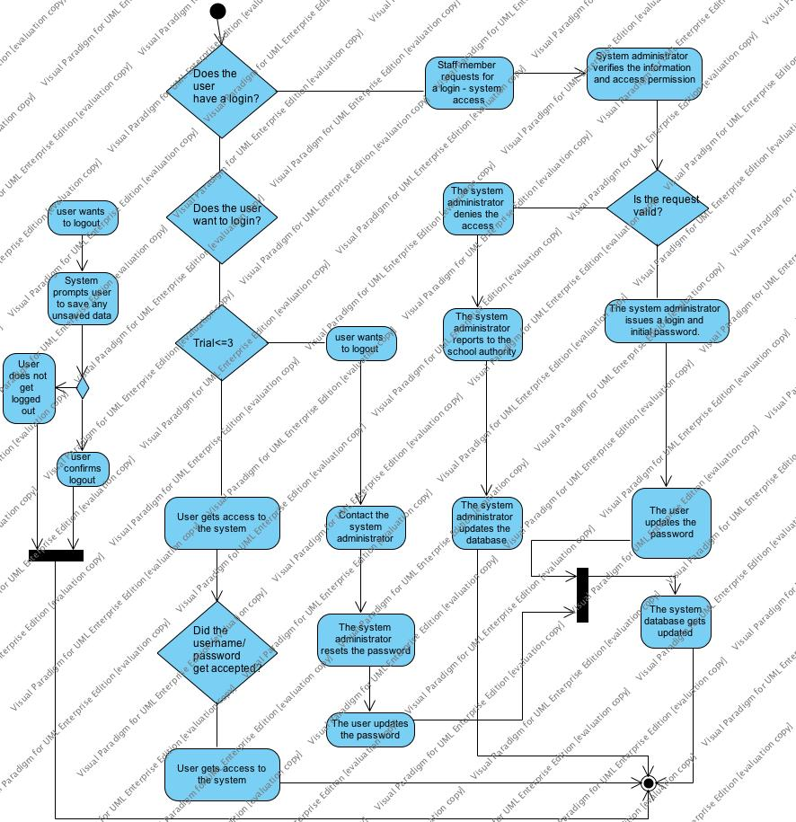

Figure 9 Activity Diagram of Whole System

## 6.4 Sequence Diagram of View Transaction



Figure 10 Sequence Diagram of View Transaction

### 6.4.1 Sequence Diagram of Verify user



Figure 11 Sequence Diagram of Verify user

### 6.4.2 Sequence Diagram of Fund Transfer



Figure 12 Sequence Diagram of Verify user

## 6.6 CLASS DIAGRAMS

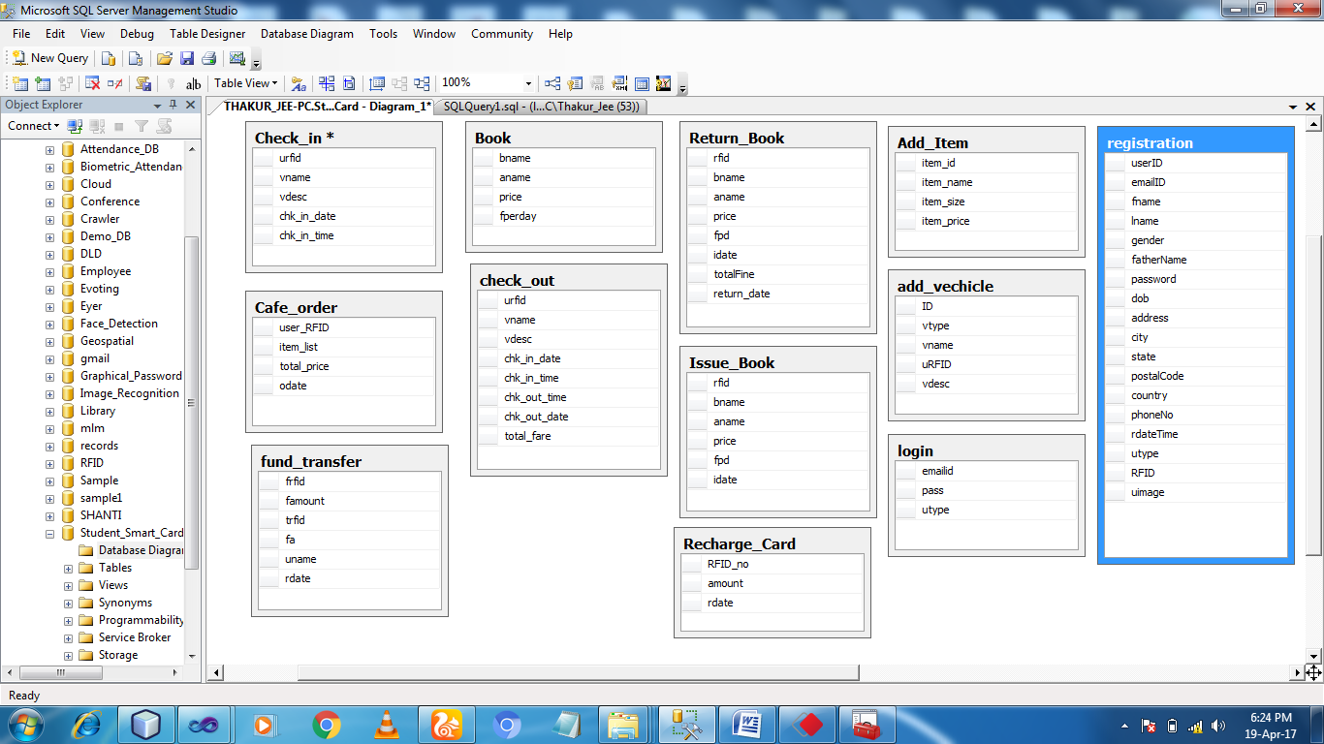

Figure 13 Class Diagram1

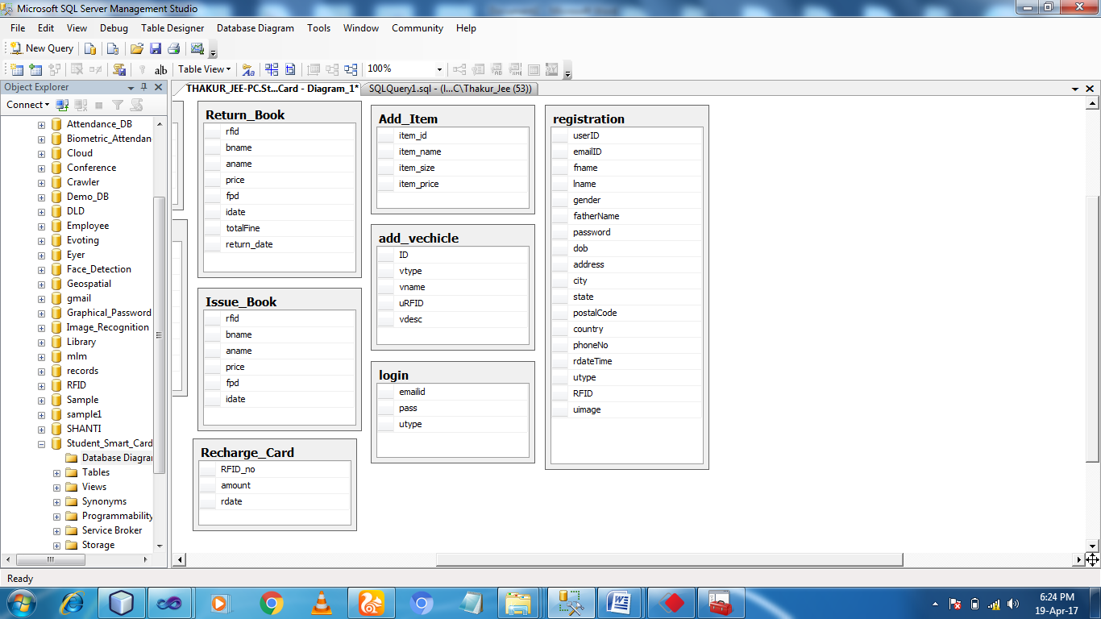

Figure 14 Class Diagram2

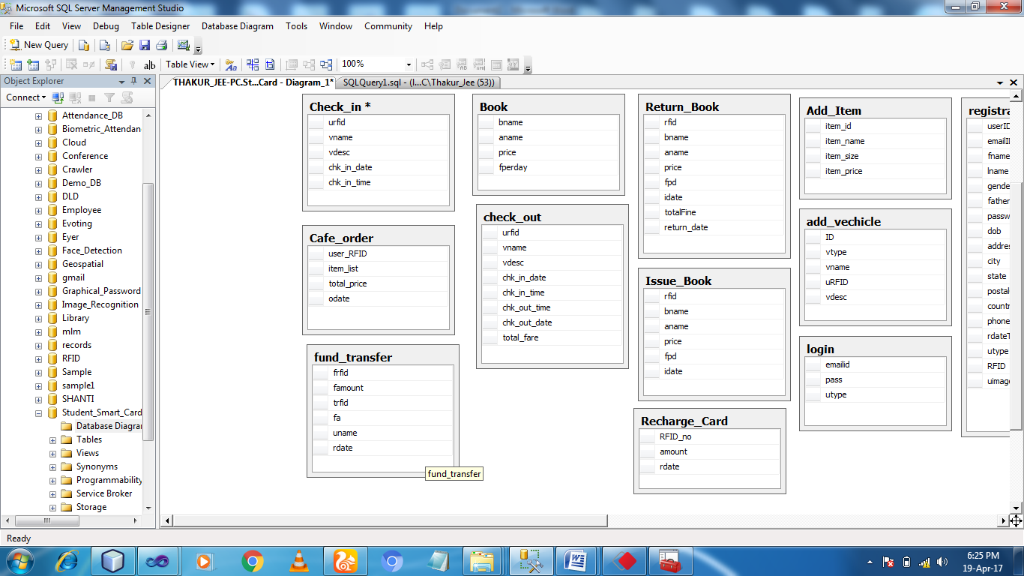

Figure 15 Class Diagram3

## 6.5 Entity Relationship Diagram



Figure 16 Entity Relationship Diagram

|  |
| --- |
| CHAPTER 7: IMPLEMENTATION |

## 7.1 Introduction

Now developer has finished the designing part of the system so developer must go for the next stage called implementation. Implementation phase is one of the most essential stages of any project as the developer would work to implement the system design into a real system. Implementation is one of the important and biggest part of the system developed life cycle and it involves code the system using programming language (ASP.NET with C#) and use the technology to implement the system and transfer the design into actual working system, which takes lot of effort and time. All the academic research (research on tools and technology) are used to implement the system (refer academic research for more details on technology used).

## 7.2 Tools Used for Modelling and Implementation

The developer has mentioned all the tools that has been used in the development of the system.

|  |  |  |
| --- | --- | --- |
| **Development & Programming IDEs** | **Case Tools** | **Others** |
| 1. .Net SDK 4.0 + 2. Visual Studio 2010 professional 3. MS FrontPage 2007 4. Adobe Photoshop 9.0 5. Internet Explorer 6.0 6. Mozilla Firefox 2.0 & 3.0 7. SQL Server 2008 Express 8. SQL Server Management Studio | 1. MS Project 2007 2. MS Visio 2007 3. Smart Draw 2007 4. AJAX Toolkit 5. Cascading Style Sheets. | 1. MS Word 2007 2. MS PowerPoint 2007 3. Windows XP with Service Pack 2 4. Other operating system like Windows Vista. |

Table 4 Implementation Tools

## 7.3 Hardware Requirements:

The hardware resources that are required in this project for developing and running the system are:

|  |
| --- |
| CPU: Pentium IV with 2.40 GHz |
| Hard Drive Space: At least 50GB Free space |
| Memory: Minimum 2 GB RAM |
| Monitor: Any Standard Monitor. |
| Graphic Card: Intel HD Graphic with 64MB |
| Keyboard / Mouse for data input |

Table 5 Hardware Tools

## 7.4 Implementation Plan

Firstly, developer prepared implementation plan to develop the entire system on time. As the proposed system is divided into several modules, so developer has to arrange the module in such an order so that no two modules conflict with each other. To accomplish this task developer assigned a priority to each and every module. The system which is of higher priority should be developed first. Some modules are complex so they require extra time and extra efforts to complete on time.

Some of the steps that are required to be followed in order to complete the system on time are:

* At first, developer needs to start with the user registration process. As proposed system is having five types of users one is **Admin**, one is **Library, one is Cafe, one is Student** and other is a **Parking**. So developer should first create a form to register them along with their privileges type.
* After user registration developer should go for the creation of login module.
* Now developer needs to develop different privileges screen one for user and other for admin.
* Admin Control is the main module of the proposed system so developer needs to start on developing the admin control module now as this is one of the primary requirements of the proposed system. Some of the functions created in this module will work as an input to other module.
* After completing above stated module, developer can start the making of normal user pages like view recharge account, search the user, give feedback etc.
* The developer now can begin to develop the customization part of the system.
* After completing all the administrative and the client site module, the developer able to start create help file for all modules so that user can easily understand the system and can perform operation more easily.

## 7.5 Implementation Approach Followed



As per the above flowchart developer has started implementation process taking input from design documents. He first created the database and then an architectural implementation is done. After implementing business layer, the developer started implementing modules one by one. At the last, developer has integrated all the modules. The output achieved from implementation will now act as an input for next phase – Testing

## 7.6 PROBLEMS OCCURRED DURING REGISTARATION MODULE IMPLEMENTATION

The problem occurred during the registration module implementation was that the name 'PostBack' does not exist in the current context. The developer reviewed the code and found that error was coming due to using postBack.

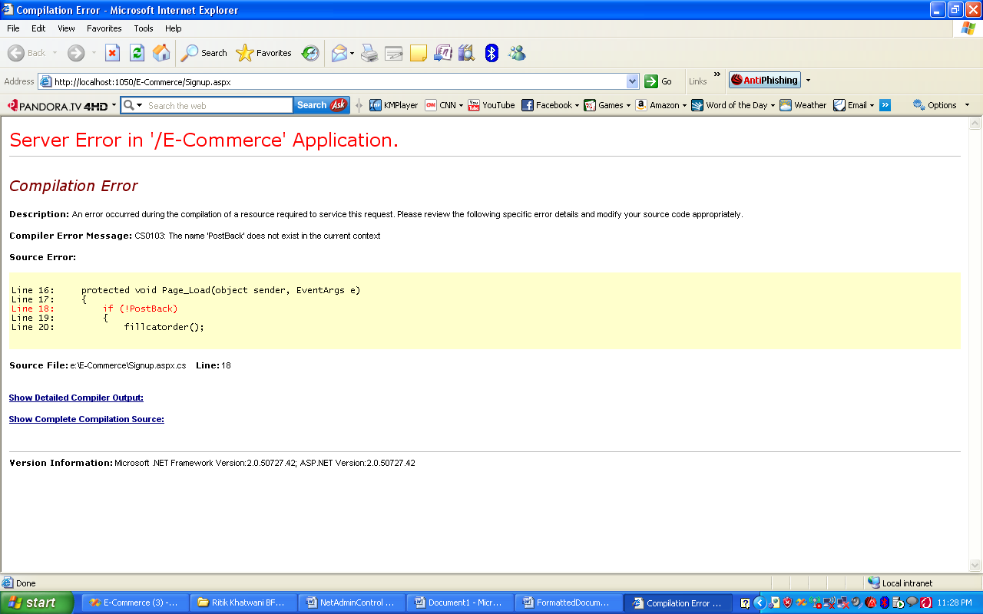

### 7.6.1 SOLUTION FOR ENCOUNTERED PROBLEM

After spending a lot of time or research developer rectified error by using IsPostBack in place of PostBack. IsPostBack: Gets a Value indicating whether the page is being loaded in response to client postback or if being loaded or accessed for the first time. The rectified code is as follow

protected void Page_Load(object sender, EventArgs e)

{

if (!IsPostBack)

{

fillcatorder();

}

}

Login was the second component developed by developer. As this is the requirement of proposed system for assigning privileges to user. In general, it is seen that maximum web based application run login. Only administrator has full access to the system. Other users can also access the system but with limited access. To allow the administrator and other users to login to the system according to their privilege one field of “Type” is created in the database to get user privilege level. Only administrator can register other users and has privilege to give same level access (administrator) to other users. Only administrator can customize the system.

## 7.7 Implementation of Modules

**Login**

|  |
| --- |
| **Login** |
| **Objective** |
| Login is implemented with the purpose to increase the security and privacy of the system. Also some of the features can be only provided to a particular user through their unique Id. |
| **Description** |
| For Login into the system the admin and user is required to have a valid username and password which they will get after doing the successful registration. |

|  |
| --- |
| **Pseudo code** |
| START  Make Connection with the Database  IF (User registered) THEN  Enter Username and Password  IF (Username and Password present in Registration table) THEN  IF(Valid Username and Password) THEN  Session is maintained and ID is taken  IF (Account is block) THEN  Error Message is shown to the user that ID is blocked ELSE  Login Successfully and Home Page is displayed  END IF ELSE  Error Message comes that please enter correct username and password.  END IF  END IF  ELSE  Register User  END IF  STOP |
| **Flow Chart** |
| START  Login  Username and  Password  Invalid  Valid  Home page  STOP    Figure 17 Flow Chart of Login |

### 7.7.1 Complex Feature:

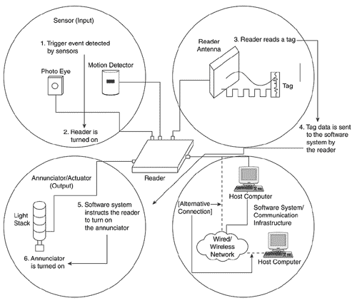

Figure 18 RFID Mechanism

int rfid_bal = 0, rfid_bal_cafe = 0;

int total_amt = Convert.ToInt32(txtTotal.Text);

// User Balance

con.open_connection();

string str = "select * from Recharge_Card where RFID_no='" + txtTag.Text + "'";

SqlCommand cmd = new SqlCommand(str, con.con_pass());

SqlDataReader dr = cmd.ExecuteReader();

if (dr.Read())

{

rfid_bal = Convert.ToInt32(dr["amount"].ToString());

}

con.close_connection();

//Cafe User Balance

con.open_connection();

string str_lib_card = "select * from Recharge_Card where RFID_no='" + Session["rfid_card"] + "'";

SqlCommand cmd_lib_card = new SqlCommand(str_lib_card, con.con_pass());

SqlDataReader dr1 = cmd_lib_card.ExecuteReader();

if (dr1.Read())

{

rfid_bal_cafe = Convert.ToInt32(dr1["amount"].ToString());

}

con.close_connection();

double avl_bal = rfid_bal - total_amt;

con.open_connection();

string str1 = "update Recharge_card set amount='" + avl_bal + "' where RFID_no='" + txtTag.Text + "'";

SqlCommand cmd1 = new SqlCommand(str1, con.con_pass());

cmd1.ExecuteNonQuery();

con.close_connection();

//update Balance of Cafe

double cafe_bal = rfid_bal_cafe + total_amt;

con.open_connection();

string str_lib = "update Recharge_card set amount='" + cafe_bal + "' where RFID_no='" + Session["rfid_card"].ToString() + "'";

SqlCommand cmd_lib = new SqlCommand(str_lib, con.con_pass());

cmd_lib.ExecuteNonQuery();

con.close_connection();

//Generate Statement

foreach (ListItem item in ListBox1.Items)

{

string Text = item.Text;

ArrayList ar = new ArrayList();

ar.Add(Text);

for (int i = 0; i < ar.Count; i++)

{

lblItems.Text += ar[i].ToString() + ",";

}

}

con.open_connection();

string st_stm = "insert into cafe_order values ('" + txtTag.Text + "','" + lblItems.Text + "','" + txtTotal.Text + "','" + System.DateTime.Now.ToString() + "')";

SqlCommand cmd_stm = new SqlCommand(st_stm, con.con_pass());

cmd_stm.ExecuteNonQuery();

con.close_connection();

lblmsg.Text = "Your Bill Has been Generated !!!!!";

### 7.7.2 Logically Complex Feature

<%@ Page Title="" Language="C#" MasterPageFile="~/Admin.master" AutoEventWireup="true" CodeFile="admin_view_user_graph_Gender.aspx.cs" Inherits="admin_view_user_graph" %>

<asp:Content ID="Content1" ContentPlaceHolderID="head" Runat="Server">

</asp:Content>

<asp:Content ID="Content2" ContentPlaceHolderID="ContentPlaceHolder1" Runat="Server">

<asp:ScriptManager ID="ScriptManager1" runat="server">

</asp:ScriptManager>

<asp:UpdatePanel ID="view" runat="server">

<ContentTemplate>

<center>

<h1><u>View User Graph</u></h1>

<asp:Chart ID="Chart1" runat="server" DataSourceID="SqlDataSource1">

<Series>

<asp:Series Name="Series1" XValueMember="gender" YValueMembers="Expr1">

</asp:Series>

</Series>

<ChartAreas>

<asp:ChartArea Name="ChartArea1">

</asp:ChartArea>

</ChartAreas>

</asp:Chart>

<asp:SqlDataSource ID="SqlDataSource1" runat="server"

ConnectionString="<%$ ConnectionStrings:StudentSmartCard %>"

SelectCommand="SELECT gender, COUNT(gender) AS Expr1 FROM [registration] GROUP BY gender"></asp:SqlDataSource>

</center>

</ContentTemplate>

</asp:UpdatePanel>

</asp:Content>

### 7.7.3 Complex Feature of language or coding used

<%@ Page Title="" Language="C#" MasterPageFile="~/Admin.master" AutoEventWireup="true" CodeFile="viewUser.aspx.cs" Inherits="viewDonar" %>

<asp:Content ID="Content1" ContentPlaceHolderID="head" Runat="Server">

</asp:Content>

<asp:Content ID="Content2" ContentPlaceHolderID="ContentPlaceHolder1" Runat="Server">

<asp:ScriptManager ID="ScriptManager1" runat="server">

</asp:ScriptManager>

<asp:UpdatePanel ID="uppnl" runat="server">

<ContentTemplate>

<center>

<div style="overflow:auto;width:900px;">

</div>

<asp:GridView ID="GridView1" runat="server" AllowPaging="True"

AllowSorting="True" AutoGenerateColumns="False" BackColor="White"

BorderColor="#999999" BorderStyle="None" BorderWidth="1px" CellPadding="3"

GridLines="Vertical" DataKeyNames="userID"

onrowdeleting="GridView1_RowDeleting">

<AlternatingRowStyle BackColor="#DCDCDC" />

<Columns>

<asp:BoundField DataField="userID" HeaderText="User ID"

SortExpression="userID" />

<asp:TemplateField HeaderText="Image" SortExpression="image">

<ItemTemplate><asp:Image ID="userImage" runat="server" ImageAlign="Left" ImageUrl='<%# Bind("uimage") %>' Height="150px" Width="170px" /></ItemTemplate>

</asp:TemplateField>

<asp:BoundField DataField="emailID" HeaderText="Email ID"

SortExpression="emailID" />

<asp:BoundField DataField="fname" HeaderText="First Name" SortExpression="fname" />

<asp:BoundField DataField="lname" HeaderText="Last Name" SortExpression="lname" />

<asp:BoundField DataField="gender" HeaderText="Gender"

SortExpression="gender" />

<asp:BoundField DataField="fatherName" HeaderText="Father Name"

SortExpression="fatherName" />

<asp:BoundField DataField="dob" HeaderText="DOB" SortExpression="dob" />

<asp:BoundField DataField="address" HeaderText="Address"

SortExpression="address" />

<asp:BoundField DataField="state" HeaderText="State" SortExpression="state" />

<asp:BoundField DataField="phoneNo" HeaderText="Phone No."

SortExpression="phoneNo" />

<asp:BoundField DataField="rdateTime" HeaderText="Registration Date"

SortExpression="rdateTime" />

<asp:CommandField HeaderText="Delete" ShowDeleteButton="True"

ShowHeader="True" />

</Columns>

<FooterStyle BackColor="#CCCCCC" ForeColor="Black" />

<HeaderStyle BackColor="#000084" Font-Bold="True" ForeColor="White" />

<PagerStyle BackColor="#999999" ForeColor="Black" HorizontalAlign="Center" />

<RowStyle BackColor="#EEEEEE" ForeColor="Black" />

<SelectedRowStyle BackColor="#008A8C" Font-Bold="True" ForeColor="White" />

<SortedAscendingCellStyle BackColor="#F1F1F1" />

<SortedAscendingHeaderStyle BackColor="#0000A9" />

<SortedDescendingCellStyle BackColor="#CAC9C9" />

<SortedDescendingHeaderStyle BackColor="#000065" />

</asp:GridView>

<asp:SqlDataSource ID="SqlDataSource1" runat="server"

ConnectionString="<%$ ConnectionStrings:StudentSmartCard %>"

SelectCommand="SELECT [userID], [emailID], [fname], [lname], [gender], [fatherName], [dob], [address], [state], [phoneNo], [rdateTime] FROM [registration]">

</asp:SqlDataSource>

</center>

</ContentTemplate>

</asp:UpdatePanel>

</asp:Content>

### 7.7.4 Technical Quality UI

<%@ Master Language="C#" AutoEventWireup="true" CodeFile="MasterPage.master.cs" Inherits="MasterPage" %>

<!DOCTYPE html PUBLIC "-//W3C//DTD XHTML 1.0 Transitional//EN" "http://www.w3.org/TR/xhtml1/DTD/xhtml1-transitional.dtd">

<html xmlns="http://www.w3.org/1999/xhtml">

<head id="Head1" runat="server">

<title></title>

<asp:ContentPlaceHolder id="head" runat="server">

</asp:ContentPlaceHolder>

<link href="style.css" rel="stylesheet" type="text/css" media="screen" />

<script type="text/javascript" src="js/jquery-1.6.3.min.js" ></script>

<script type="text/javascript" src="js/jquery-ui.min.js" ></script>

<script type="text/javascript">

$(document).ready(function () {

$("#featured > ul").tabs({ fx: { opacity: "toggle"} }).tabs("rotate", 5000, true);

});

</script>

<link rel="stylesheet" type="text/css" href="css/ddsmoothmenu.css" />

<script type="text/javascript" src="js/ddsmoothmenu.js">

</script>

<script type="text/javascript">

ddsmoothmenu.init({

mainmenuid: "tooplate_menu", //menu DIV id

orientation: 'h', //Horizontal or vertical menu: Set to "h" or "v"

classname: 'ddsmoothmenu', //class added to menu's outer DIV

//customtheme: ["#1c5a80", "#18374a"],

contentsource: "markup" //"markup" or ["container_id", "path_to_menu_file"]

})

</script>

<link rel="stylesheet" href="css/slimbox2.css" type="text/css" media="screen" />

<script type="text/JavaScript" src="js/slimbox2.js"></script>

<link rel="stylesheet" href="css/slides.css" type="text/css" media="screen" />

<link href="style.css" rel="stylesheet" type="text/css" media="screen" />

</head>

<div style="background:red; width:870px;margin-left:230px;margin-top:-20px;" >

<marquee onmouseover="stop();" onmouseout="start();" ><center><h1 style="color:yellow;margin-top:auto;">Student Smart Card</h1></center></marquee>

</div><br />

<body>

<div id="wrapper">

<div id="header">

<div id="menu">

<ul>

<li><a href="Default.aspx">Home</a></li>

<li><a href="login.aspx">Login</a></li>

<li><a href="about.aspx">About</a></li>

<li><a href="contact.aspx">Contact</a></li>

</ul>

</div>

<!-- end #menu -->

<div id="search">

<form method="get" action="">

<fieldset>

&nbsp;

</fieldset>

</form>

</div>

<!-- end #search -->

</div>

<!-- end #header -->

<div class="slides" style="width: 900px;height: 218px;">

<ul>

<!-- slides -->

<li>

<img class="b" src="images/1.jpg" alt="img1" /> </li>

<li>

<img class="b" src="images/2.jpg" alt="img2" /> </li>

<li>

<img class="b" src="images/3.jpg" alt="img3" /> </li>

<li>

<img class="b" src="images/5.png" alt="img4" /> </li>

</ul>

</div>

<hr />

<!-- end #logo -->

<!-- end #header-wrapper -->

<div id="page">

<div id="content1">

<center><div class="post">

<h2 class="title1">Welcome to Student Smart Card</h2>

</center>

</div>

<!-- end #content -->

<!-- end #sidebar -->

<form id="form1" runat="server">

<div>

<asp:ContentPlaceHolder id="ContentPlaceHolder1" runat="server">

</asp:ContentPlaceHolder>

</div>

</form>

</div>

<!-- end #page -->

<div id="footer">

<p>Copyright (c) 2017 Student Smart Card</p>

</div>

<!-- end #footer -->

</div>

</body>

</html>

### 7.4.5 Functional Quality

#### 7.4.5.1 Sending Mail

protected void SendMail()

{

// Gmail Address from where you send the mail

var fromAddress = "trymelater111@gmail.com";

// any address where the email will be sending

var toAddress = txtEmail.Text;

//Password of your gmail address

const string fromPassword = "trymelater";

// Passing the values and make a email formate to display

string subject = "WELCOME to Student Smart Card Please Write Down Your User Name and Password";

string body = "Student Smart Card" + "\n";

body += "User Name: " + txtEmail.Text + "\n";

body += "Password: " + txtPass.Text + "\n";

body += "Description:Thanks for Registerning with us" + "\n";

// smtp settings

var smtp = new System.Net.Mail.SmtpClient();

{

smtp.Host = "smtp.gmail.com";

smtp.Port = 587;

smtp.EnableSsl = true;

smtp.DeliveryMethod = System.Net.Mail.SmtpDeliveryMethod.Network;

smtp.Credentials = new NetworkCredential(fromAddress, fromPassword);

smtp.Timeout = 20000;

}

// Passing values to smtp object

smtp.Send(fromAddress, toAddress, subject, body);

}

#### 7.4.5.2 End Sending mail

int rfid_bal = 0, rfid_bal_lib=0;

DateTime dt = Convert.ToDateTime(Session["idate"].ToString());

DateTime dt1 = Convert.ToDateTime(System.DateTime.Now.ToShortDateString().ToString());

TimeSpan t = dt1 - dt;

double NrOfDays = t.TotalDays;

lblDisp.Text = NrOfDays.ToString();

//Calculate Total Fine

int fpd = Convert.ToInt32(txtFine.Text);

double final_Fine = fpd * NrOfDays;

//end

//Calculate User RFID Balance

con.open_connection();

string str = "select * from Recharge_Card where RFID_no='" + txtTag.Text + "'";

SqlCommand cmd = new SqlCommand(str, con.con_pass());

SqlDataReader dr = cmd.ExecuteReader();

if (dr.Read())

{

rfid_bal = Convert.ToInt32(dr["amount"].ToString());

}

con.close_connection();

con.open_connection();

string str_lib_card = "select * from Recharge_Card where RFID_no='" + Session["rfid_card"] + "'";

SqlCommand cmd_lib_card = new SqlCommand(str_lib_card, con.con_pass());

SqlDataReader dr1 = cmd_lib_card.ExecuteReader();

if (dr1.Read())

{

rfid_bal_lib = Convert.ToInt32(dr1["amount"].ToString());

}

con.close_connection();

//end

//Dedudct Total Fine from available Balance

if (rfid_bal <= 100)

{

lblDisp.Text = "Your Card Not Having Suffucient Balance";

}

else

{

double avl_bal = rfid_bal - final_Fine;

con.open_connection();

string str1 = "update Recharge_card set amount='" + avl_bal + "' where RFID_no='" + txtTag.Text + "'";

SqlCommand cmd1 = new SqlCommand(str1, con.con_pass());

cmd1.ExecuteNonQuery();

con.close_connection();

//update Balance of Library

double lib_bal = rfid_bal_lib + final_Fine;

con.open_connection();

string str_lib = "update Recharge_card set amount='" + lib_bal + "' where RFID_no='" + Session["rfid_card"].ToString() + "'";

SqlCommand cmd_lib = new SqlCommand(str_lib, con.con_pass());

cmd_lib.ExecuteNonQuery();

con.close_connection();

// delete from Issue Book

con.open_connection();

string str2 = "Delete from Issue_book where bname='"+DropDownList1.SelectedItem+"'";

SqlCommand cmd2 = new SqlCommand(str2, con.con_pass());

cmd2.ExecuteNonQuery();

con.close_connection();

//end

//Insert Value into Statement Table

con.open_connection();

string str_Return = "insert into Return_Book values ('" + txtTag.Text + "','" + DropDownList1.SelectedItem + "','" + txtAuthor.Text + "','" + txtPrice.Text + "','" + txtFine.Text + "','" + Session["idate"] + "','" + final_Fine + "','"+System.DateTime.Now.ToShortDateString()+"')";

SqlCommand cmd_Return = new SqlCommand(str_Return, con.con_pass());

cmd_Return.ExecuteNonQuery();

con.close_connection();

//end

lblDisp.Text = "Book Return Successfully";

}

## 7.5 Performance

* The developed system is flexible to work on any web Based device with very less specification, with same efficiency.
* The system performance is not hindered by the processor speed of the device.
* The application is flexible to work on slower net connectivity.

## 7.6 User Interface

* User interface are following HCIU principles that are mentioned before.
* The size of text-fields is taken appropriately.
* Further user interface details will be mentioned on GUI and Usability testing.

## 7.7 Comments

Comments are one of the most significant aspects which describe the application technical quality. It supports the developer in re-reading the source code after a long time. Thus, relevant comments are provided for understanding.

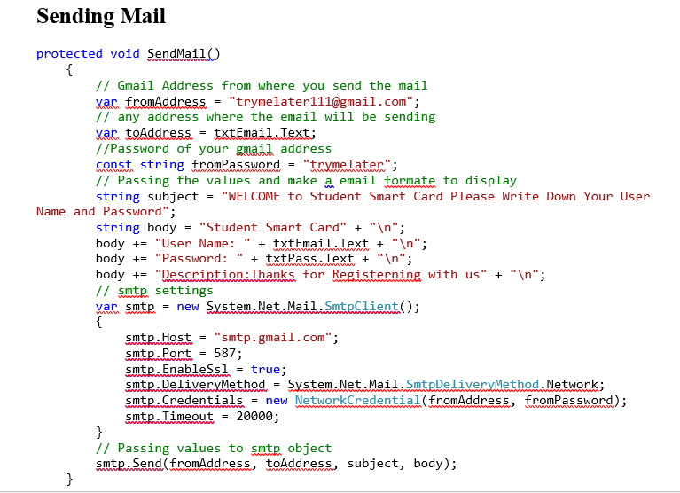

Figure 19 Comments

## 7.8 User Manual

This manual provides very simple and quick steps for running this application by walking you through the Sample Tasks.

**Home**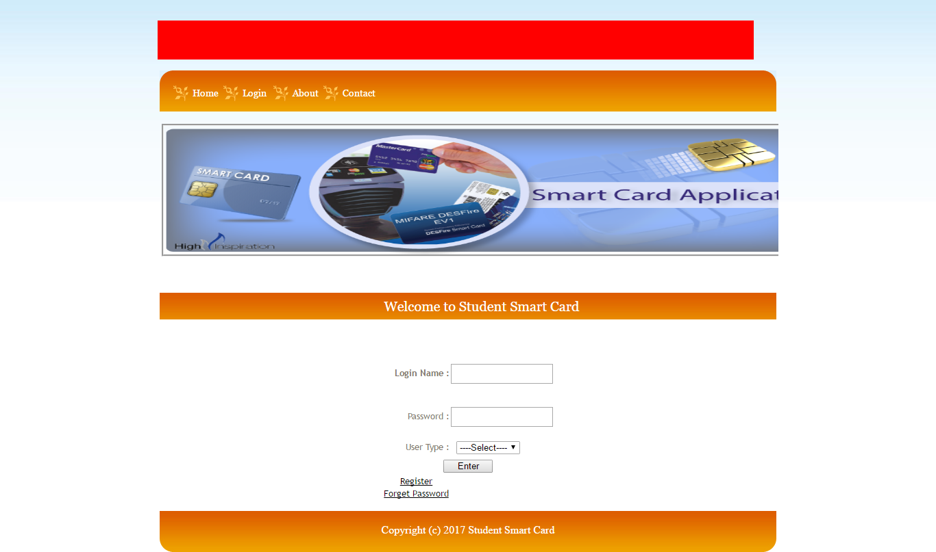

This is the Home of the system. This is the login page where the preregistered users can login using their Login name and Password. After Login User can access other functionalities.

### 7.8.1 Admin Module

#### 7.8.1.1 User ListC:\Users\Arup\Desktop\FYP\User Manual Screenshot\Admin\User List.png

This is admin page where he can see all the users registered to the program. Admin can also remove any user as per his wish.

#### 7.8.1.2 View All type of user graphC:\Users\Arup\Desktop\FYP\User Manual Screenshot\Admin\View All Type Of User Graph.png

Admin can see the graph plotted for All Type of Users in graph view. Admin manages the accounts of different users preregistered to the system.

#### 7.8.1.3 Recharge CardC:\Users\Arup\Desktop\FYP\User Manual Screenshot\Admin\Recharge Card.png

This is the Recharge Card page where the Smart Card is recharged for further usage. Admin has the authority to recharge registered users Smart Card.

### 7.8.2 Student Module

#### 7.8.2.1 View Profile C:\Users\Arup\Desktop\FYP\User Manual Screenshot\Student\View Student Profile.png

Student can see his/her profile as per registered details. The details and the photograph can be changed anytime using change image and edit profile option.

#### 7.8.2.2 View Balance C:\Users\Arup\Desktop\FYP\User Manual Screenshot\Student\View Balance.png

Students can also see the available balance left in their Card.

#### 7.8.2.3 View Transaction C:\Users\Arup\Desktop\FYP\User Manual Screenshot\Student\View Transaction.png

Students are able to view their recent transactions made with the system.

#### 7.8.2.4 Fund Transfer C:\Users\Arup\Desktop\FYP\User Manual Screenshot\Student\Fund Transfer.png

Fund transfer is also an option for the user where the user can transfer fund in others Smart Card user and vice-versa.

#### 7.8.2.5 Change Password C:\Users\Arup\Desktop\FYP\User Manual Screenshot\Student\Change Password.png

The user is also allowed to change the password of the ID whenever he feels the need to change.

### 7.8.3 Library Module

#### 7.8.3.1 Add Book C:\Users\Arup\Desktop\FYP\User Manual Screenshot\Library\Add Book.png

Library Staff can use these for registering the books to the database.

#### 7.8.3.2 View Book C:\Users\Arup\Desktop\FYP\User Manual Screenshot\Library\View Book.png

User is allowed to view book details feed into the database whenever required.

#### 7.8.3.3 Issue Book C:\Users\Arup\Desktop\FYP\User Manual Screenshot\Library\Issue Book.pngL

Library user issues book to the registered students.

#### 7.8.3.4 Return Book C:\Users\Arup\Desktop\FYP\User Manual Screenshot\Library\Return Book.png

Student can easily return book just by verifying their identity.

#### 7.8.3.5 View Transaction C:\Users\Arup\Desktop\FYP\User Manual Screenshot\Library\View Transaction.png

User is allowed to see their recent library transactions.

### 7.8.4 Cafe Module

7.8.4.1AddItems 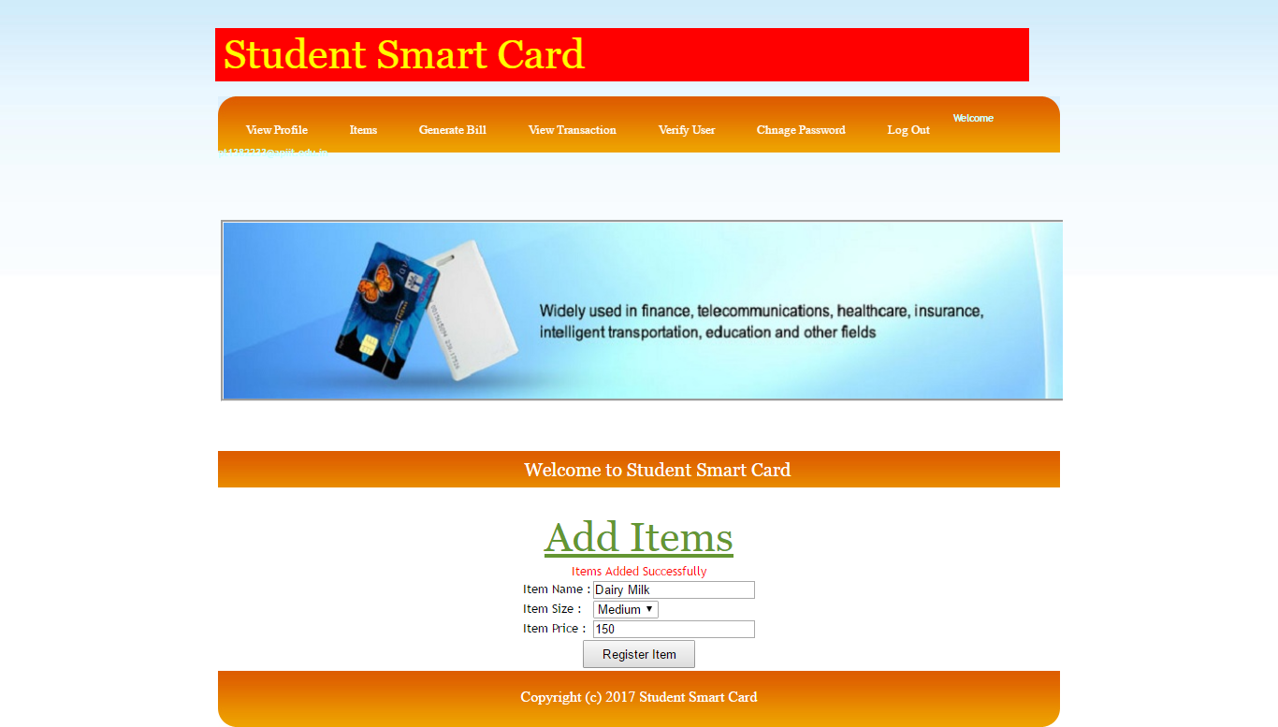Cafe user is allowed to add items into their database.

#### 7.8.4.2 View Items C:\Users\Arup\Desktop\FYP\User Manual Screenshot\Cafe\View Items.png

Cafe users are able to see the list or the menu of items available in the cafe.

#### 7.8.4.3 Generate Bill C:\Users\Arup\Desktop\FYP\User Manual Screenshot\Cafe\Generate Bill.png

Bills can be generated by the user for different items that are purchased by Students.

#### 7.8.4.4 View Transaction C:\Users\Arup\Desktop\FYP\User Manual Screenshot\Cafe\View Transaction.png

Cafe user can view all his recent transactions made.

### 7.8.5 Parking Module

#### 7.8.5.1 Add Vehicle C:\Users\Arup\Desktop\FYP\User Manual Screenshot\Parking\Add Vehicle.png

This page is used to add or register a new vehicle into the database of the parking.

#### 7.8.5.2 View vehicle C:\Users\Arup\Desktop\FYP\User Manual Screenshot\Parking\View Vehicle.png

Parking user can anytime see the list of the vehicles registered to the database.

7.8.5.3 Check-In 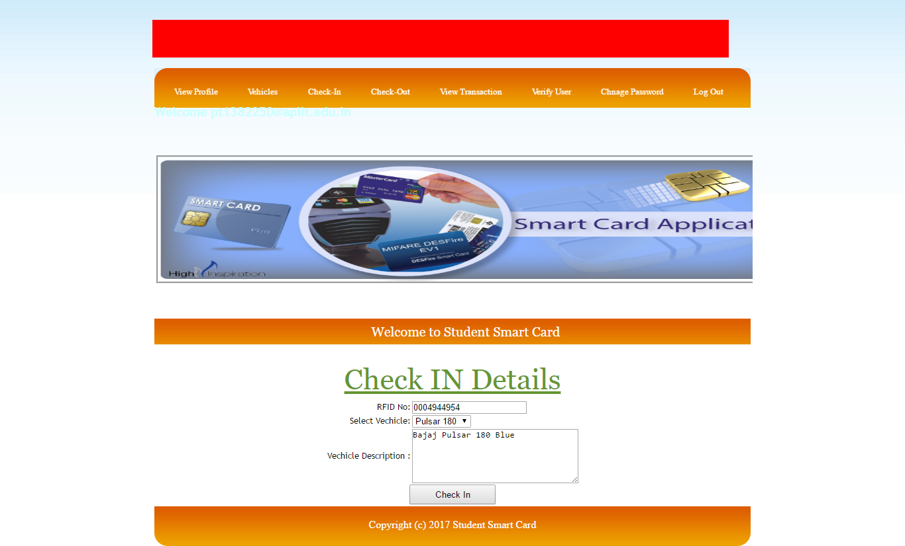

Parking user can check in using the page above just by filling the RFID No. and giving vehicle description.

#### 7.8.5.4 Check-Out C:\Users\Arup\Desktop\FYP\User Manual Screenshot\Parking\Check-out.png

Parking user can track their check in and check out time using this feature of student smart card.

#### 7.8.5.5 View Transaction C:\Users\Arup\Desktop\FYP\User Manual Screenshot\Parking\View Transaction.png

Parking user can easily track their last transactions using the window above.

|  |
| --- |
| CHAPTER 8: TESTING |

## 8.1 Introduction

The objective of testing is to identify errors and rectify them in order to deliver an error free quality system. It is done with utmost carefulness and patience to find out all possible errors and fix them. Testing will be performed according to the test plan and result will be used to correct errors in the next iteration. The reasons for testing are given below:

* Free system from bugs and errors
* Meet user requirements in correct manner
* Improve consistency
* Efficiency of the developed system

## 8.2 Testing Approach

A testing plan is a methodological and systematic approach to testing the system and is quite effective in finding bugs and errors in the system. It includes the testing techniques to be followed by the developer so as to enhance the quality of the system. Various testing techniques to be implemented for Student Smart Card are given in the next section.

## 8.3 Types of Testing

Figure 20 Types of Testing

|  |  |  |  |
| --- | --- | --- | --- |
| **S. No.** | **Testing Technique** | **Requirement** | |
|  | **Unit Testing** | | Testing of individual software component or modules of the system. This type of testing is performed by the developers only because it requires detailed knowledge of the internal program design and code. It includes performing black box and white box testing. |
|  | **Integration Testing** | | Testing of integration modules to verify combined functionality after integration. Various modules are integrated together and then tested by the developer of the system to check whether the modules work properly after integration. |
|  | **System Testing** | | Entire system is tested by the developer as per the requirements. All the modules of the system are combined and check whether they work perfectly after being integrated into one system as a whole. |
|  | **Compatibility Testing** | | Compatibility testing is used to determine if the system causes any issues related to how it function in concern with the operating system and different type of system hardware and software. The developer performs this type of testing on various hardware/ software platform to test the compatibility of the system on each platform. |
|  | **GUI Testing** | | The testing is to be done to verify the design of the system whether it satisfies the six predefined HCIU design principle and whether the system named ShopDroid is user friendly. |
|  | **Usability Testing** | | The purpose of doing a usability test is to determine whether a product or document works with its intended users or readers. This is to be done by evaluating a product through observing the real people actually working on or using it so as to improve or enhance the system. The end- users execute the system to test it |
|  | **User Acceptance Testing** | | User Acceptance Testing tests that the system satisfies all the essential user requirements and is performing to the acceptable level as expected by the customer. This is done by defining a set of acceptance criteria which the system must satisfy before the customer will accept it. |
|  | **Documentation Testing** | | Documentation Testing is to be done to verify the system documentation whether it is meaningful and user friendly or not. |

Table 6 Types of Testing Explained Briefly

## 8.4 Pass/Fail Criteria

* The produced system meets all the specifications mentioned in the project specification form and all the requirements of the user gathered during the research phase.
* All the modules/ functionalities are implemented in a way that the desired system produced runs without any bugs and error.
* System is to be verified for the usability that depends upon proven Human-Computer Interaction (HCI) principles and aims to achieve in the application ease of use, Navigation, time for completion and errors removal.
* It is checked that if the system is connecting with the database and returning corrects field values.

## 8.5 Test Cases

#### 8.5.1.1 Home

|  |  |  |  |  |  |  |  |
| --- | --- | --- | --- | --- | --- | --- | --- |
| **Project Name** | | Student Smart Card | | | | |  |
| **Test Case ID** | | SSC01 | | **Test Case Name** | | Home |  |
| **Testing Priority** | | Medium | | **Tester** | | Developer |  |
| **Testing Date** | | 10th March, 2017 | | **Testing Duration** | | 2 hours |  |
| **Description** | | Allow users to visit home of the system. | | | | |  |
| **Pre-Condition** | | User should click on the Home tab from the menu. | | | | |  |
| **Module** | **Test Steps** | | **Expected Result** | | **Actual Result** | | **Status** |
| 1.1 | Click on Register for new user registration. | | Registration Page is displayed | | Same as Expected Result | | Pass |
| 1.2 | Click on Login to Login into desired modules. | | After proper Input login to desired modules. | | Same as Expected Result | | Pass |
| 1.3 | Click on About to know system briefly. | | About Student Smart Card is shown. | | Same as Expected Result. | | Pass |

Table 7 Home Test

#### 8.5.1.2 Registration

|  |  |  |  |  |  |  |  |  |  |
| --- | --- | --- | --- | --- | --- | --- | --- | --- | --- |
| **Project Name** | | Student Smart Card | | | | | |  | |
| **Test Case ID** | | SSC02 | | **Test Case Name** | | | Registration |  | |
| **Testing Priority** | | Medium | | **Tester** | | | Developer |  | |
| **Testing Date** | | 10th March, 2017 | | **Testing Duration** | | | 2 hours |  | |
| **Description** | | Allow users to register into the system. | | | | | |  | |
| **Pre-Condition** | | User should click on the registration tab from the home menu. | | | | | |  | |
| **Module** | **Test Steps** | | **Expected Result** | | **Actual Result** | | | **Status** | |
| 2.1 | Select the Registration from the menu | | Registration Page is displayed | | Registration Page is displayed | | | Pass | |
| 2.2 | Enter any special character in the name  field | | No input is taken | | Input alphanumeric only | | | Pass | |
| 2.3 | Enter password | | No error message | | No error message | | | Pass | |
| 2.4 | Add the email id with wrong format | | Error Message should be shown | | Error message come that enter valid email id. | | | Pass | |
| 2.5 | Add phone number | | Error Message should be shown | | Error shown that enter phone no of 10 digits | | | Pass | |
| 2.6 | Add all the fields with already present userid and click on Register button. | | Error message should be shown that userid already exist | | Data Entered successfully and registration is done. | | | Pass | |
| 2.7 | Add all the fields and with email id which is already present in database. | | Error Message should be shown that email id already exist | | Data Entered successfully and registration is done. | | | Fail | |
| **Result:** One error found in the Registration page.(Module 2.7) | | | | | | | | | |
| **Measures Taken:** Developer has implemented the validations over the userID and email id field that first it will search the email from the database if it will be already present then the error message will come and user has to enter another email id. | | | | | | | | | |
| **Review Test Case for failed Results** | | | | | | | | | |
| 2.8 | Add the email id which is already present in database. | | Error Message should be shown that email id already exist | | | Error shown that email id already exists | | | Pass |
| **Post-Condition** | | Registration is done successfully and now user can login into the system | | | | | | | |

Table 8 Registration Test

#### 8.5.1.3 Login

|  |  |  |  |  |  |  |  |
| --- | --- | --- | --- | --- | --- | --- | --- |
| **Project Name** | | Student Smart card | | | | | |
| **Test Case ID** | | SSC03 | | **Test Case Name** | | Login | |
| **Testing Priority** | | Medium | | **Tester** | | Developer | |
| **Testing Date** | | 10th March, 2017 | | **Testing Duration** | | 2 hours | |
| **Description** | | Allow users to login into the system | | | | | |
| **Pre-Condition** | | User should be registered and user must click on login from menu. | | | | | |
| **Module** | **Test Steps** | | **Expected Result** | | **Actual Result** | | **Status** |
| 3.1 | Select the Login from the menu | | Login Page is displayed | | Login Page is displayed | | Pass |
| 3.2 | Enter invalid username and password and click on submit button | | Error message should be shown that Wrong username or password | | Error shown that Name & Password Does not Match | | Pass |
| 3.3 | Enter valid username and password and click on Enter button | | Successfully login into the system | | Successfully login into the system | | Pass |
| 3.4 | Select User Type | | Successfully desired User Type is to be selected. | | Successfully desired User Type is selected. | | Pass |
| 3.5 | Click on Forget Password | | Password Module is displayed and enter details. Field should not be kept empty. | | Same as Expected Result. | | Pass |
| **Post-Condition** | | Login is done successfully and now use other functionalities. | | | | | |

Table 9 Login Test Case

### 8.5.2 Student Module

#### 8.5.2.1 View Profile

|  |  |  |  |  |  |  |  |
| --- | --- | --- | --- | --- | --- | --- | --- |
| **Project Name** | | Student Smart card | | | | | |
| **Test Case ID** | | SSC04 | | **Test Case Name** | | View Profile | |
| **Testing Priority** | | Medium | | **Tester** | | Developer | |
| **Testing Date** | | 12th March, 2017 | | **Testing Duration** | | 2 hours | |
| **Description** | | Allow student users to view their profile details. | | | | | |
| **Pre-Condition** | | User should be registered and user must click on login from menu. | | | | | |
| **Module** | **Test Steps** | | **Expected Result** | | **Actual Result** | | **Status** |
| 4.1 | Select Change image from Registration details | | Profile Image option to choose and upload Image. | | Profile Image option to choose and upload Image is done. | | Pass |
| 4.2 | Select Edit Profile | | User details should get updated. | | Phone No and Email Id is updated. | | Pass |
| **Post-Condition** | | Login is done successfully and now use other functionalities. | | | | | |

Table 10 View Profile Test Case

#### 8.5.2.2 View transaction

|  |  |  |  |  |  |  |  |
| --- | --- | --- | --- | --- | --- | --- | --- |
| **Project Name** | | Student Smart card | | | | | |
| **Test Case ID** | | SSC05 | | **Test Case Name** | | View transaction | |
| **Testing Priority** | | Medium | | **Tester** | | Developer | |
| **Testing Date** | | 12th March, 2017 | | **Testing Duration** | | 2 hours | |
| **Description** | | Allow student users to view transaction details. | | | | | |
| **Pre-Condition** | | User should be registered and user must click on login from menu. | | | | | |
| **Module** | **Test Steps** | | **Expected Result** | | **Actual Result** | | **Status** |
| 5.1 | Click on View Transaction to view user transaction. | | User Transaction detail is displayed. | | User Transaction detail is displayed. | | Pass |
| **Post-Condition** | | Login is done successfully and now use other functionalities. | | | | | |

Table 11 View Transaction Test Case

#### 8.5.2.3 Fund Transfer

|  |  |  |  |  |  |  |  |
| --- | --- | --- | --- | --- | --- | --- | --- |
| **Project Name** | | Student Smart card | | | | | |
| **Test Case ID** | | SSC06 | | **Test Case Name** | | Fund Transfer | |
| **Testing Priority** | | Medium | | **Tester** | | Developer | |
| **Testing Date** | | 12th March, 2017 | | **Testing Duration** | | 2 hours | |
| **Description** | | Allow student users to transfer funds in different RFID no. | | | | | |
| **Pre-Condition** | | User should be registered and user must click on login from menu. | | | | | |
| **Module** | **Test Steps** | | **Expected Result** | | **Actual Result** | | **Status** |
| 6.1 | Select the Credited RFID text field. | | RFID no should be scanned and get entered automatically. | | RFID no is scanned and get entered automatically. | | Pass |
| 6.2 | Enter Amount more than Available Amount. | | Successfully fund should be transferred and Available amount goes for debt. | | Successfully fund transferred and it shows – balance. | | Pass |
| 6.3 | Enter valid Amount to transfer | | Successfully fund should be transferred. | | Successfully fund transferred. | | Pass |
| **Post-Condition** | | Login is done successfully and now use other functionalities. | | | | | |

Table 12 Fund Transfer Test Case

### 8.5.3 Admin Module

#### 8.5.3.1 User List

|  |  |  |  |  |  |  |  |
| --- | --- | --- | --- | --- | --- | --- | --- |
| **Project Name** | | Student Smart card | | | | | |
| **Test Case ID** | | SSC07 | | **Test Case Name** | | User List | |
| **Testing Priority** | | Medium | | **Tester** | | Developer | |
| **Testing Date** | | 16th March, 2017 | | **Testing Duration** | | 2 hours | |
| **Description** | | Allow Admin to view User List | | | | | |
| **Pre-Condition** | | User should be registered in database and user must click on login from menu. | | | | | |
| **Module** | **Test Steps** | | **Expected Result** | | **Actual Result** | | **Status** |
| 7.1 | Click on Delete to Delete user from User List | | User deleted from User List | | Same as expected result. | | Pass |
| **Post-Condition** | | User List accessed and modified successfully and now use other functionalities. | | | | | |

Table 13 User List Test Case

#### 8.5.3.2 View Graph

|  |  |  |  |  |  |  |  |
| --- | --- | --- | --- | --- | --- | --- | --- |
| **Project Name** | | Student Smart card | | | | | |
| **Test Case ID** | | SSC08 | | **Test Case Name** | | View Graph | |
| **Testing Priority** | | Medium | | **Tester** | | Developer | |
| **Testing Date** | | 16th March, 2017 | | **Testing Duration** | | 2 hours | |
| **Description** | | Allow Admin to view Graph of users. | | | | | |
| **Pre-Condition** | | User should be registered in database and user must click on login from menu. | | | | | |
| **Module** | **Test Steps** | | **Expected Result** | | **Actual Result** | | **Status** |
| 8.1 | Click on All Type User to view user graph | | All type of User Graph is to be displayed. | | All Type User Graph is displayed. | | Pass |
| 8.2 | Click on Gender wise to view gender wise user graph | | Gender wise User Graph is to be displayed. | | Gender wise User Graph is displayed. | | Pass |
| **Post-Condition** | | View Graph is accessed and now use other functionalities. | | | | | |

Table 14 View Graph Test Case

#### 8.5.3.3 Recharge Card

|  |  |  |  |  |  |  |  |
| --- | --- | --- | --- | --- | --- | --- | --- |
| **Project Name** | | Student Smart card | | | | | |
| **Test Case ID** | | SSC09 | | **Test Case Name** | | Recharge Card | |
| **Testing Priority** | | Medium | | **Tester** | | Developer | |
| **Testing Date** | | 21st March, 2017 | | **Testing Duration** | | 2 hours | |
| **Description** | | Allow Admin to recharge Students Smart Card with RFID no. | | | | | |
| **Pre-Condition** | | User should be registered and user must click on login from menu. | | | | | |
| **Module** | **Test Steps** | | **Expected Result** | | **Actual Result** | | **Status** |
| 9.1 | Select RFID Card No text field. | | RFID Card no should be entered. | | RFID no is scanned and get entered automatically. | | Pass |
| 9.2 | Enter Amount to be credited. | | Smart Card should be recharged and message is displayed. | | Successfully Recharged Card and message is also displayed. | | Pass |
| 9.3 | Enter invalid Amount to be credited. | | No Successful Recharge take place. | | Nor any Successful Recharge take place neither any message is displayed. | | Pass |
| **Post-Condition** | | Recharge Card is done successfully and now use other functionalities. | | | | | |

Table 15 Recharge Card Test Case

#### 8.5.3.4 LogOut

|  |  |  |  |  |  |  |  |
| --- | --- | --- | --- | --- | --- | --- | --- |
| **Project Name** | | Student Smart card | | | | | |
| **Test Case ID** | | SSC10 | | **Test Case Name** | | LogOut | |
| **Testing Priority** | | Medium | | **Tester** | | Developer | |
| **Testing Date** | | 21st March, 2017 | | **Testing Duration** | | 2 hours | |
| **Description** | | Allow Admin to get Logout. | | | | | |
| **Pre-Condition** | | User should be registered in database and user must click on login from menu. | | | | | |
| **Module** | **Test Steps** | | **Expected Result** | | **Actual Result** | | **Status** |
| 10.1 | Click on LogOut to logout. | | Admin should be logged out and return to home. | | Same as expected result. | | Pass |
| **Post-Condition** | | LogOut is accessed successfully and now use other functionalities. | | | | | |

Table 16 LogOut Test Case

### 8.5.4 Library Module

#### 8.5.4.1 Book

|  |  |  |  |  |  |  |  |
| --- | --- | --- | --- | --- | --- | --- | --- |
| **Project Name** | | Student Smart card | | | | | |
| **Test Case ID** | | SSC11 | | **Test Case Name** | | Book | |
| **Testing Priority** | | Medium | | **Tester** | | Developer | |
| **Testing Date** | | 21st March, 2017 | | **Testing Duration** | | 2 hours | |
| **Description** | | Allow Library users to add, view, issue, return book. | | | | | |
| **Pre-Condition** | | User should be registered and user must click on login from menu. | | | | | |
| **Module** | **Test Steps** | | **Expected Result** | | **Actual Result** | | **Status** |
| 11.1 | Click on Add Book for addition of book. | | Register book details is displayed and field should not be kept empty. | | Book Details Added Successfully message is displayed. | | Pass |
| 11.2 | Click on View book to overlook books that are added. | | View Book Details page is displayed. | | Same as Expected Result. | | Pass |
| 11.3 | Click on Issue book to issue book to users. | | Successful message of book issued should be displayed. | | Book Issued Successfully is displayed. | | Pass |
| 11.4 | Click on return book to return book from users. | | Successful message of book return should be displayed. | | Book Returned Successfully is displayed. | | Pass |
| **Post-Condition** | | Book is accessed successfully and now use other functionalities. | | | | | |

Table 17 Book Test Case

#### 8.5.4.2 View transaction

|  |  |  |  |  |  |  |  |
| --- | --- | --- | --- | --- | --- | --- | --- |
| **Project Name** | | Student Smart card | | | | | |
| **Test Case ID** | | SSC12 | | **Test Case Name** | | View transaction | |
| **Testing Priority** | | Medium | | **Tester** | | Developer | |
| **Testing Date** | | 21st March, 2017 | | **Testing Duration** | | 2 hours | |
| **Description** | | Allow library users to view transaction details. | | | | | |
| **Pre-Condition** | | User should be registered and user must click on login from menu. | | | | | |
| **Module** | **Test Steps** | | **Expected Result** | | **Actual Result** | | **Status** |
| 12.1 | Click on View Transaction to view Library transaction. | | Library Transaction details are to be displayed. | | Library Transaction details are displayed. | | Pass |
| **Post-Condition** | | View transaction is done successfully and now use other functionalities. | | | | | |

Table 18 View Transaction Test Case

#### 8.5.4.3 Verify user

|  |  |  |  |  |  |  |  |
| --- | --- | --- | --- | --- | --- | --- | --- |
| **Project Name** | | Student Smart card | | | | | |
| **Test Case ID** | | SSC13 | | **Test Case Name** | | Verify User | |
| **Testing Priority** | | Medium | | **Tester** | | Developer | |
| **Testing Date** | | 23rd March, 2017 | | **Testing Duration** | | 2 hours | |
| **Description** | | Allow library users to verify User | | | | | |
| **Pre-Condition** | | User should be registered and user must click on login from menu. | | | | | |
| **Module** | **Test Steps** | | **Expected Result** | | **Actual Result** | | **Status** |
| 13.1 | Click on Enter RFID No field and get automatically scanned using Reader. | | Registration Details of verified user is to be displayed. | | Registration Details of verified user is displayed. | | Pass |
| **Post-Condition** | | Verify User is done successfully and now use other functionalities. | | | | | |

Table 19 Verify User Test Case

#### 8.5.4.4 Change Password

|  |  |  |  |  |  |  |  |
| --- | --- | --- | --- | --- | --- | --- | --- |
| **Project Name** | | Student Smart card | | | | | |
| **Test Case ID** | | SSC14 | | **Test Case Name** | | Change Password | |
| **Testing Priority** | | Medium | | **Tester** | | Developer | |
| **Testing Date** | | 23rd March, 2017 | | **Testing Duration** | | 2 hours | |
| **Description** | | Allow library users to change current Password. | | | | | |
| **Pre-Condition** | | User should be registered and user must click on login from menu. | | | | | |
| **Module** | **Test Steps** | | **Expected Result** | | **Actual Result** | | **Status** |
| 14.1 | Click on Change Password to change user’s password | | Password changed message is to be displayed. | | Password changed Successfully message is displayed. | | Pass |
| **Post-Condition** | | Change Password is accessed successfully and now use other functionalities. | | | | | |

Table 20 Change Password Test Case

#### 8.5.4.5 LogOut

|  |  |  |  |  |  |  |  |
| --- | --- | --- | --- | --- | --- | --- | --- |
| **Project Name** | | Student Smart card | | | | | |
| **Test Case ID** | | SSC15 | | **Test Case Name** | | LogOut | |
| **Testing Priority** | | Medium | | **Tester** | | Developer | |
| **Testing Date** | | 23rd March, 2017 | | **Testing Duration** | | 2 hours | |
| **Description** | | Allow Admin to get Logout. | | | | | |
| **Pre-Condition** | | User should be registered in database and user must click on login from menu. | | | | | |
| **Module** | **Test Steps** | | **Expected Result** | | **Actual Result** | | **Status** |
| 15.1 | Click on LogOut to logout. | | Library user should be logged out and return to home. | | Same as expected result. | | Pass |
| **Post-Condition** | | LogOut is accessed successfully and now use other functionalities. | | | | | |

Table 21 Logout Test Case

### 8.5.5 Parking Module

#### 8.5.5.1 Vehicles

|  |  |  |  |  |  |  |  |
| --- | --- | --- | --- | --- | --- | --- | --- |
| **Project Name** | | Student Smart card | | | | | |
| **Test Case ID** | | SSC16 | | **Test Case Name** | | Vehicles | |
| **Testing Priority** | | Medium | | **Tester** | | Developer | |
| **Testing Date** | | 23rd March, 2017 | | **Testing Duration** | | 2 hours | |
| **Description** | | Allow Parking users to add, view vehicles. | | | | | |
| **Pre-Condition** | | User should be registered and user must click on login from menu. | | | | | |
| **Module** | **Test Steps** | | **Expected Result** | | **Actual Result** | | **Status** |
| 16.1 | Click on Add Vehicles for addition of vehicle. | | Add vehicle Module is displayed and field should not be kept empty. | | Register Vehicle Successfully message is displayed. | | Pass |
| 16.2 | Click on View vehicle to overlook vehicle that are added. | | Register Vehicle Details page is displayed. | | Same as Expected Result. | | Pass |
| **Post-Condition** | | Vehicle is accessed successfully and now use other functionalities. | | | | | |

Table 22 Vehicle Test Case

#### 8.5.5.2 Check-in

|  |  |  |  |  |  |  |  |
| --- | --- | --- | --- | --- | --- | --- | --- |
| **Project Name** | | Student Smart card | | | | | |
| **Test Case ID** | | SSC17 | | **Test Case Name** | | Check-in | |
| **Testing Priority** | | Medium | | **Tester** | | Developer | |
| **Testing Date** | | 28th March, 2017 | | **Testing Duration** | | 2 hours | |
| **Description** | | Allow users to check-in. | | | | | |
| **Pre-Condition** | | User should be registered and user must click on login from menu. | | | | | |
| **Module** | **Test Steps** | | **Expected Result** | | **Actual Result** | | **Status** |
| 17.1 | Click on Check-in. | | Check-in details is to be displayed. | | Check-in details is displayed. | | Pass |
| 17.2 | Click on RFID No field and get automatically scanned using Reader. | | Registered user is to be displayed. | | Registered user is displayed. | | Pass |
| 17.3 | Select Vehicle from list | | Selected vehicle description should be displayed. | | Selected vehicle description is displayed. | | Pass |
| 17.4 | Click on Check in | | Check In message is to be displayed. | | Check In Successfully message is displayed. | | Pass |
| **Post-Condition** | | Check-in is accessed successfully and now use other functionalities. | | | | | |

Table 23 Check-in Test Case

#### 8.5.5.3 Check-Out

|  |  |  |  |  |  |  |  |
| --- | --- | --- | --- | --- | --- | --- | --- |
| **Project Name** | | Student Smart card | | | | | |
| **Test Case ID** | | SSC18 | | **Test Case Name** | | Check-Out | |
| **Testing Priority** | | Medium | | **Tester** | | Developer | |
| **Testing Date** | | 28th March, 2017 | | **Testing Duration** | | 2 hours | |
| **Description** | | Allow users to check-Out. | | | | | |
| **Pre-Condition** | | User should be registered and user must click on login from menu. | | | | | |
| **Module** | **Test Steps** | | **Expected Result** | | **Actual Result** | | **Status** |
| 18.1 | Click on Check-Out. | | Check-Out details is to be displayed. | | Check-Out details is displayed. | | Pass |
| 18.2 | Click on RFID No field and get automatically scanned using Reader. | | Registered user is to be displayed. | | Registered user is displayed. | | Pass |
| 18.3 | Select Vehicle from list | | Selected vehicle description should be displayed. | | Selected vehicle description is displayed. | | Pass |
| 18.4 | Click on Check Out | | Check Out message is to be displayed. | | Check Out Successfully message is displayed. | | Pass |
| **Post-Condition** | | Check-Out is accessed successfully and now use other functionalities. | | | | | |

Table 24 Check-Out Test Case

#### 8.5.5.4 View Transaction

|  |  |  |  |  |  |  |  |
| --- | --- | --- | --- | --- | --- | --- | --- |
| **Project Name** | | Student Smart card | | | | | |
| **Test Case ID** | | SSC19 | | **Test Case Name** | | View Transaction | |
| **Testing Priority** | | Medium | | **Tester** | | Developer | |
| **Testing Date** | | 28th March, 2017 | | **Testing Duration** | | 2 hours | |
| **Description** | | Allow Parking users to view transaction details. | | | | | |
| **Pre-Condition** | | User should be registered and user must click on login from menu. | | | | | |
| **Module** | **Test Steps** | | **Expected Result** | | **Actual Result** | | **Status** |
| 19.1 | Click on View Transaction to view Parking transaction. | | Parking Transaction details are to be displayed after RFID No is inserted. | | Parking Transaction details are displayed. | | Pass |
| **Post-Condition** | | View Transaction is done successfully and now use other functionalities. | | | | | |

Table 25 View Transaction Test Case

#### 8.5.5.5 Change Password

|  |  |  |  |  |  |  |  |
| --- | --- | --- | --- | --- | --- | --- | --- |
| **Project Name** | | Student Smart card | | | | | |
| **Test Case ID** | | SSC20 | | **Test Case Name** | | Change Password | |
| **Testing Priority** | | Medium | | **Tester** | | Developer | |
| **Testing Date** | | 28th March, 2017 | | **Testing Duration** | | 2 hours | |
| **Description** | | Allow Parking user to change current Password. | | | | | |
| **Pre-Condition** | | User should be registered and user must click on login from menu. | | | | | |
| **Module** | **Test Steps** | | **Expected Result** | | **Actual Result** | | **Status** |
| 20.1 | Click on Change Password to change user’s password | | Password changed message is to be displayed. | | Password changed Successfully message is displayed. | | Pass |
| **Post-Condition** | | Change Password is accessed successfully and now use other functionalities. | | | | | |

Table 26 Change Password Test Case

#### 8.5.5.6 Log Out

|  |  |  |  |  |  |  |  |
| --- | --- | --- | --- | --- | --- | --- | --- |
| **Project Name** | | Student Smart card | | | | | |
| **Test Case ID** | | SSC21 | | **Test Case Name** | | Log Out | |
| **Testing Priority** | | Medium | | **Tester** | | Developer | |
| **Testing Date** | | 28th March, 2017 | | **Testing Duration** | | 2 hours | |
| **Description** | | Allow Parking user to Log Out. | | | | | |
| **Pre-Condition** | | User should be registered in database and user must click on login from menu. | | | | | |
| **Module** | **Test Steps** | | **Expected Result** | | **Actual Result** | | **Status** |
| 21.1 | Click on Log Out to logout. | | Parking user sould be logged out and return to home. | | Same as expected result. | | Pass |
| **Post-Condition** | | Log Out is accessed successfully and now use other functionalities. | | | | | |

Table 27 Log Out Test Case

### 8.5.6 Cafe Module

#### 8.5.6.1 Items

|  |  |  |  |  |  |  |  |
| --- | --- | --- | --- | --- | --- | --- | --- |
| **Project Name** | | Student Smart card | | | | | |
| **Test Case ID** | | SSC22 | | **Test Case Name** | | Items | |
| **Testing Priority** | | Medium | | **Tester** | | Developer | |
| **Testing Date** | | 28th March, 2017 | | **Testing Duration** | | 2 hours | |
| **Description** | | Allow Cafe users to add, view items. | | | | | |
| **Pre-Condition** | | User should be registered and user must click on login from menu. | | | | | |
| **Module** | **Test Steps** | | **Expected Result** | | **Actual Result** | | **Status** |
| 22.1 | Click on Add Item for addition of items. | | Add Item Module is displayed and field should not be kept empty. | | Items Added Successfully message is displayed. | | Pass |
| 22.2 | Click on View Item to overlook Items that are added. | | View Items Details page is to be displayed. | | Same as Expected Result. | | Pass |
| **Post-Condition** | | Items is accessed successfully and now use other functionalities. | | | | | |

Table 28 Items Test Case

#### 8.5.6.2 Generate Bill

|  |  |  |  |  |  |  |  |
| --- | --- | --- | --- | --- | --- | --- | --- |
| **Project Name** | | Student Smart card | | | | | |
| **Test Case ID** | | SSC23 | | **Test Case Name** | | Generate Bill | |
| **Testing Priority** | | Medium | | **Tester** | | Developer | |
| **Testing Date** | | 30th March, 2017 | | **Testing Duration** | | 2 hours | |
| **Description** | | Allow cafe user to Generate Bill. | | | | | |
| **Pre-Condition** | | User should be registered and user must click on login from menu. | | | | | |
| **Module** | **Test Steps** | | **Expected Result** | | **Actual Result** | | **Status** |
| 23.1 | Click on RFID No field and it get automatically scanned. | | Generate Bill is displayed and field should not be kept empty. | | Generate Bill panel is displayed. | | Pass |
| **Post-Condition** | | Generate Bill is accessed successfully and now use other functionalities. | | | | | |

Table 29 Generate Bill Test Case

#### 8.5.6.3 View Transaction

|  |  |  |  |  |  |  |  |
| --- | --- | --- | --- | --- | --- | --- | --- |
| **Project Name** | | Student Smart card | | | | | |
| **Test Case ID** | | SSC24 | | **Test Case Name** | | View Transaction | |
| **Testing Priority** | | Medium | | **Tester** | | Developer | |
| **Testing Date** | | 30th March, 2017 | | **Testing Duration** | | 2 hours | |
| **Description** | | Allow Cafe user to view transaction details. | | | | | |
| **Pre-Condition** | | User should be registered and user must click on login from menu. | | | | | |
| **Module** | **Test Steps** | | **Expected Result** | | **Actual Result** | | **Status** |
| 24.1 | Click on View Transaction to view Cafe transaction. | | Cafe Transaction details are to be displayed. | | Cafe Transaction details are displayed. | | Pass |
| **Post-Condition** | | View Transaction is done successfully and now use other functionalities. | | | | | |

Table 30 View Transaction Test Case

#### 8.5.6.4 Verify user

|  |  |  |  |  |  |  |  |
| --- | --- | --- | --- | --- | --- | --- | --- |
| **Project Name** | | Student Smart card | | | | | |
| **Test Case ID** | | SSC25 | | **Test Case Name** | | Verify User | |
| **Testing Priority** | | Medium | | **Tester** | | Developer | |
| **Testing Date** | | 30th March, 2017 | | **Testing Duration** | | 2 hours | |
| **Description** | | Allow Cafe users to verify User | | | | | |
| **Pre-Condition** | | User should be registered and user must click on login from menu. | | | | | |
| **Module** | **Test Steps** | | **Expected Result** | | **Actual Result** | | **Status** |
| 25.1 | Click on Enter RFID No field and get automatically scanned using Reader. | | Registration Details of verified user is to be displayed. | | Registration Details of verified user is displayed. | | Pass |
| **Post-Condition** | | Verify User is done successfully and now use other functionalities. | | | | | |

Table 31 Verify User Test Case

#### 8.5.6.5 Change Password

|  |  |  |  |  |  |  |  |
| --- | --- | --- | --- | --- | --- | --- | --- |
| **Project Name** | | Student Smart card | | | | | |
| **Test Case ID** | | SSC26 | | **Test Case Name** | | Change Password | |
| **Testing Priority** | | Medium | | **Tester** | | Developer | |
| **Testing Date** | | 4th April, 2017 | | **Testing Duration** | | 2 hours | |
| **Description** | | Allow Parking user to change current Password. | | | | | |
| **Pre-Condition** | | User should be registered and user must click on login from menu. | | | | | |
| **Module** | **Test Steps** | | **Expected Result** | | **Actual Result** | | **Status** |
| 26.1 | Click on Change Password to change user’s password | | Password changed message is to be displayed. | | Password changed Successfully message is displayed. | | Pass |
| **Post-Condition** | | Change Password is accessed successfully and now use other functionalities. | | | | | |

Table 32 Change Password Test Case

#### 8.5.6.6 Log Out

|  |  |  |  |  |  |  |  |
| --- | --- | --- | --- | --- | --- | --- | --- |
| **Project Name** | | Student Smart card | | | | | |
| **Test Case ID** | | SSC27 | | **Test Case Name** | | Log Out | |
| **Testing Priority** | | Medium | | **Tester** | | Developer | |
| **Testing Date** | | 4th April, 2017 | | **Testing Duration** | | 2 hours | |
| **Description** | | Allow Admin to get Logout. | | | | | |
| **Pre-Condition** | | User should be registered in database and user must click on login from menu. | | | | | |
| **Module** | **Test Steps** | | **Expected Result** | | **Actual Result** | | **Status** |
| 27.1 | Click on Log Out to logout. | | Cafe user should be logged out and return to home. | | Same as expected result. | | Pass |
| **Post-Condition** | | Log Out is accessed successfully and now use other functionalities. | | | | | |

Table 33 Log Out Test Case

## 8.6 White Box testing

White Box Testing is the testing technique that examines the program structure and derives test data from the program logic/code. It focuses primarily on strengthening security, the flow of inputs and outputs through the application, and improving design and usability. White box testing is also known as clear, open, structural, and glass box testing.

### 8.6.1 Justification for white box testing

The white box testing is very beneficial for our project as it will reveal the errors in the hidden code. This type of testing requires the knowledge of the internal coding that‘s why it is done by the developer who develops the system. It will remove the extra lines of code from the proposed project. In this testing the dead code and other issues are spotted out very easily and effectively.

## 8.7 Integration Testing

Integration Testing is a testing technique that combines the individual units or the modules of the system and integrated them together to be tested whether the modules work properly as expected after integration or produce any bugs. The purpose of this testing to achieve the following:

* Each module should integrate with each other without any data loss.
* Each module should be independent of each other while running.
* To conduct incremental testing starting from lower level in the unit testing.

### 8.7.1 Technique Used for Integration Testing

In this testing the developer will follow the Bottom up integration approach in which developer make sure that first modules at the lower level are integrated together and tested and after this the developer should got for the main program modules. So now the main or higher level modules should be integrated together and tested.

### 8.7.2 Justification of Integration Testing

Integration Testing is applicable when the developer has tested all the modules of the system individually. After testing individual modules, modules are integrated together to be tested whether they work properly after integration. For example, Login module is integrated with Registration module because user can manage login after they are registered. Similarly, in Check-out version of Parking module is integrated with Check-in because user can check-out from Parking only when he/she Check-in.

### 8.7.3 Registration + Login

|  |  |  |  |  |  |  |  |
| --- | --- | --- | --- | --- | --- | --- | --- |
| **Project Name** | | Student Smart Card | | | | | |
| **Test Case ID** | | SSC_IT01 | | **Test Case Name** | | Registration+Login | |
| **Testing Priority** | | Medium | | **Tester** | | Developer | |
| **Testing Date** | | 23rd March, 2017 | | **Testing Duration** | | 5 hours | |
| **Description** | | Allow users register and Login into the system. | | | | | |
| **Pre-Condition** | | User must open home. | | | | | |
| **Unit Test cases** | | SSC02, SSC03 | | | | | |
| **Module** | **Test Steps** | | **Expected Result** | | **Actual Result** | | **Status** |
| IT01-01 | Click on Register | | User is registered. | | Same as Expected Result. | | Pass |
| IT01-02 | Click on Login | | User is Logged in. | | User is Logged in. | | Pass |
| **Post-Condition** | | Registration and Login is done successfully in the system. | | | | | |

Table 34 Registration + Login

8.7.4 Check-In + Check-Out

|  |  |  |  |  |  |  |  |
| --- | --- | --- | --- | --- | --- | --- | --- |
| **Project Name** | | Student Smart Card | | | | | |
| **Test Case ID** | | SSC_IT02 | | **Test Case Name** | | Check-In + Check-Out | |
| **Testing Priority** | | Medium | | **Tester** | | Developer | |
| **Testing Date** | | 23rd March, 2017 | | **Testing Duration** | | 5 hours | |
| **Description** | | Allow users to check in and check out from the Parking system. | | | | | |
| **Pre-Condition** | | User must be log in into the system. | | | | | |
| **Unit Test cases** | | SSC17, SSC18 | | | | | |
| **Module** | **Test Steps** | | **Expected Result** | | **Actual Result** | | **Status** |
| IT02-01 | Click on Check-In | | Check In message is to be displayed when registered users insert all fields. | | Check In Successfully message is displayed. | | Pass |
| IT02-02 | Click on Check-Out | | Check Out message is to be displayed when registered users insert all fields. | | Check Out Successfully message is displayed. | | Pass |
| **Post-Condition** | | Check-In + Check-Out is done successfully in the system. | | | | | |

Table 35 Check-In + Check-Out

## 8.8 System Testing

System testing is testing used to check the behaviour of a complete and fully integrated software product based on the software requirements specification (SRS) document.System testing falls under the black box testing category of software testing.It is the testing of the complete integrated system to check whether the system fulfilled the requirement specified by the user.

### 8.8.1 Justification for System Testing

This testing is done for the proposed system to ensure that the whole integrated system works properly without any error or bugs. This testing also checks that the developer has fulfilled the requirements of the users or not.

|  |  |  |  |  |  |
| --- | --- | --- | --- | --- | --- |
| **Project**  **Name** |  | Student Smart Card | | |  |
| **Module** | **Test Steps** | | **Expected Result** | **Actual Result** | **Status** |
| ST-01 | Click on Home | | User can view home page. | Same as Expected Result. | Pass |
| ST-02 | Click on Register | | User Registration should be done after inserting all fields. | Registration Successful message is displayed. | Pass |
| ST-03 | Click on Login | | Login to selected module when name and password matches. | Login Successfully done. | Pass |
| ST-04 | Click on User List | | User List is to be displayed. | User List is displayed. | Pass |
| ST-05 | Click on All Type User from View Graph menu to view user graph | | All type of User Graph is to be displayed. | All Type User Graph is displayed. | Pass |
|  | Click on Gender wise to view gender wise from View Graph menu to view user graph | | Gender wise User Graph is to be displayed. | Gender wise User Graph is displayed. | Pass |
| ST-06 | Click on Recharge Card | | Smart Card should be recharged and message is displayed. Fields should not be empty. | Successfully Recharged Card and message is also displayed. | Pass |
| ST-07 | Click on View Profile | | Registration Details of user should be displayed. | Registration Details of user is displayed. | Pass |
|  | Click on View Balance | | Available Balance of registered user is to be displayed. | Available Balance of registered user is displayed. | Pass |
|  | Click on View Transaction | | User transaction details is to be shown. | User Transaction details is displayed. | Pass |
|  | Click on Fund Transfer | | Fund transferred successfully. Fields should not be empty. | Successfully Fund Transfer message is displayed. | Pass |
| ST-08 | Click on Add Book from Book menu | | Register book details is displayed and field should not be kept empty. | Book Details Added Successfully message is displayed. | Pass |
|  | Click on View book to overlook books that are added. | | View Book Details page is to be displayed. | View Book Details page is displayed. | Pass |
|  | Click on Issue book to issue book to users. | | Successful message of book issued should be displayed. | Book Issued Successfully is displayed. | Pass |
|  | Click on return book to return book from users. | | Successful message of book return should be displayed. | Book Returned Successfully is displayed. | Pass |
| ST-09 | Click on Enter RFID No field and get automatically scanned using Reader. | | Registration Details of verified user is to be displayed | Registration Details of verified user is displayed. | Pass |
| ST-10 | Click on Add Vehicles from Vehicles menu for addition of vehicle. | | Add vehicle Module is displayed and field should not be kept empty. | Register Vehicle Successfully message is displayed. | Pass |
|  | Click on View vehicle from Vehicles menu to overlook vehicle that are added. | | Register Vehicle Details page is displayed. | Same as Expected Result. | Pass |
| ST-11 | Click on Check-In from menu | | Field are to be inserted properly and Check in message should be displayed. | Check In Successfully message is displayed. | Pass |
| ST-12 | Click on Check-Out from menu | | Field are to be inserted properly and Check Out message should be displayed. | Check Out Successfully message is displayed. | Pass |
| ST-13 | Click on Add Item from Items for addition of items. | | Add Items dialogue box appear and field should not be kept empty. | Items Added Successfully message is displayed. | Pass |
|  | Click on View Items from Items menu to overlook Items that are added. | | View Items Details page is to be displayed. | View Items Details page is displayed. | Pass |
| ST-14 | Click on RFID No field and it get automatically scanned. | | Generate Bill is displayed and field should not be kept empty. | Generate Bill panel is displayed. | Pass |
| ST-15 | Click on Change Password from menu | | Password changed message is to be displayed. | Password changed Successfully message is displayed. | Pass |
| ST-16 | Click on Log Out from menu | | User should be logged out and return to home. | Same as Expected Result. | Pass |

Table 36 System Testing

## 8.9 Compatibility Testing

This testing is done to ensure that the system or application is also working properly on other browsers, platforms, operating system, network, hardware ‘s and software ‘s. In this it is find out that how system performs in a particular environment. If the system is compatible with all the hardware, operating system, database or other system software or not then, it is ensured that the system is stable and users will not face any kind of difficulty while using the system.

### 8.9.1 Justification for Compatibility Testing

This testing is done for the proposed system to ensure that the software can install and function on multiple environments. Software is tested on various hardware interfaces like graphics cards, headphones, various ram types, etc. The software will also be tested on various operating systems. It will check the quality and scalability of the proposed system.

|  |  |  |  |  |  |  |  |  |  |  |  |
| --- | --- | --- | --- | --- | --- | --- | --- | --- | --- | --- | --- |
| **Project Name** | | | Student Smart Card | | | | | | |  | |
| **Module** | **Test Steps** | | | | | **Expected Result** | | **Actual Result** | | **Status** | |
| **For Web Application** | | | | | | | | | |  | |
| **1. Hardware Test** | | | | | | | | | |  | |
| 1.1 | Hardware Test (As per the hardware requirement specified, Pentium IV processor, at least 2 GB Free space and 50 GB Hard Disk). | | | | The system runs perfectly with an appropriate speed without any barriers or difficulties. | | | System runs as expected. | | Pass | |
| **2. Operating System** | | | | | | | | | |  | |
| 2.1 | The system is run on the  Mac operating system | | | | System must not run on the  Mac operating system. | | | System is not running on the Mac operating system | | Pass | |
| 2.2 | The system is run on the  Windows operating  system | | | | System should run perfectly. | | | System is running properly | | Pass | |
| **3. Windows Version Test** | | | | | | | | | |  | |
| 3.1 | Windows 10 | | | | The developed system is compatible with Windows 10 without any exception or error when run on this version of windows. | | | System run smoothly without any error. | | Pass | |
| 3.2 | Windows 7 | | | | The developed system/ application should run without any errors or exception on windows 7 | | | System run smoothly without any error | | Pass | |
| 3.3 | | | Windows 8 | | | The developed system must be compatible with Windows 8 and should not cause any exception when run on this version of windows. | | System run smoothly without any error | | Pass | |
|  | | | **4. Development Platform** | | | | |  | |  | |
| 4.1 | | | Visual Studio 2008 or below | |  | The system should run perfectly without any error. | | The system doesn‘t run perfectly as it was not able to load data and controls | | Fail | |
| 4.2 | | | Visual Studio 2010 | |  | The system should run perfectly without any error. | | System runs perfectly fine. | | Pass | |
|  | | |  | | **5. Web browsers** | | |  | |  | |
| 5.1 | | | Google Chrome | |  | Application should work properly and design should remain constant. | | Application  worked and executed in a proper manner. | | Pass | |
| 5.2 | | | Mozilla Firefox | |  | Application should work properly and design should remain constant. | | Application  worked and executed in a  proper manner | | Pass | |
| 5.3 | | | Internet Explorer | |  | Application should work properly and design should remain constant. | | Application not worked in proper manner and design is not constant. | | Fail | |

Table 37 Compatibility Testing

## 8.10 GUI Testing

Graphical User Interface (GUI) testing is the process of testing the system's GUI of the System. It involves testing the screens with GUI controls such as menus, buttons, icons, and all types of bars - tool bar, menu bar, dialog boxes and windows etc. In this testing the system is tested according to the design principles.

### 8.10.1 Justification for GUI Testing

This testing is done for the proposed system to ensure that the designing of the software is good and easily readable. It is verified that in the designing everything is meaningful nothing is designed just to make the software attractive and have no usage of it.

|  |  |  |  |  |  |
| --- | --- | --- | --- | --- | --- |
| **Project Name** | Student Smart Card | | | | |
| **Test Case ID** | SSC_GUI | **Test Case Name** | System GUI test | | |
| **Testing Priority** | Medium | **Tester** | Developer | | |
| **Testing Date** | 25th March, 2017 | **Testing Duration** | 1 day | | |
| **Description** | In this the designing of the system software is tested and to check whether the interface of the system is meeting user‘s Requirement or not. | | | | |
| **Items** | **Questions** | | | **Answers** | |
| **Menu Bars** | **Does the menu labels are meaningful?** | | | **Yes** | No |
| **Does the menu bar visible properly?** | | | **Yes** | No |
| **Are the icons of the menu bar are universally acceptable?** | | | **Yes** | No |
| **Font** | **Font type and size is consistent for all the forms** | | | **Yes** | No |
| **Font size is big enough to be visible or to be read by the user** | | | **Yes** | No |
| **Textbox** | **Does the textbox clearly visible?** | | | **Yes** | No |
| **Does proper validations are applied on the textbox?** | | | **Yes** | No |
| **Background** | **Are the controls visible on the background image?** | | | **Yes** | No |
| **Does the background is user friendly?** | | | **Yes** | No |
| **Buttons** | **Do they describe the appropriate action?** | | | **Yes** | No |
| **Does the buttons have meaningful labels?** | | | **Yes** | No |
| **Are the buttons size consistent (width and height).** | | | **Yes** | No |
| **Color** | **Does the used colors are sufficient contrast to Reduce eye strain?** | | | **Yes** | No |
| **Are colors used consistently when designating Functionality?** | | | **Yes** | No |
| **Screen Design** | **Does the screen design user friendly and meaningful?** | | | **Yes** | No |
|  | **Are the screen designs consistent all over the system?** | | | **Yes** | No |
| **Message Box** | **Does error message contain are easily understandable** | | | **Yes** | No |
| **Does the error messages are descriptive and Meaningful?** | | | **Yes** | No |
| **Conclusion** | Above result shows that the graphical user interface of the proposed system is user friendly and well-designed according to the user ‘s needs. | | | | |

Table 38 GUI Testing

## 8.11 Usability Testing

Usability testing is the means for measuring the quality of a user’s experience while interacting with a product or system. Some of the users are asked to complete tasks and when they are doing the tasks they are being observed by the researcher. The goal is to identify any usability problems, collect qualitative and quantitative data and determine the participant's satisfaction with the product

### 8.11.1 Justification for usability Testing

This testing is done for the proposed system to find out what problems or difficulties users will face when they will be asked to use the system. Through this testing developer will be ensuring that the system is satisfying the needs of the users. This testing will help the developer to identify the changes required to improve user performance and satisfaction.

* **Learnability:** It measures how easy it is for end user to accomplish the system’s functionalities or how much the system’s interface is easy to execute. For example, Student Smart Card has a user friendly interface consisting of forms, buttons and other interactive GUI controls that makes it easy to learn.
* **Efficiency:** It measures how fast system’s functionalities and tasks can be executed. For example, the system is quite fast, directs the user from one activity to other efficiently.
* **Memorability:** It measures how much the end user is able to memorize the system and its functionalities when he/she accesses the system after a long period of time. For example, the interactive interface and easy of using it makes it easy for the user to memorize the functions of the system.
* **Errors:** It measures how effectively the system can recover from errors. The proposed system Student Smart Card is not prone to errors; toast message is provided wherever any error or exception is expected.
* **User Satisfaction:** It measures how much the user likes the system or satisfied with the system. For example, achievement of the above mentioned components contribute towards user satisfaction, achieving learnability, memorability, efficiency and removing errors achieve user satisfaction.

**Questionnaire**

|  |  |
| --- | --- |
|  | Was the system user friendly, easy to learn, easy to navigate through various forums or page? |
|  | Was the system efficiency while performing various tasks? |
|  | Was the system free from errors or was capable enough to recover you from errors? |
|  | Was the system easy to memorize when executed again but after a period of time? |
|  | Were you satisfied with the system completely? |

Table 39 Questionnaire for Usability Testing

**Rating Criteria**

|  |  |  |  |  |
| --- | --- | --- | --- | --- |
| Excellent-5 | Very-Good-4 | Good-3 | Average-2 | Poor-1 |

### 8.11.2 Usability Testing on the basis of five factors:

|  |  |  |  |  |  |  |  |
| --- | --- | --- | --- | --- | --- | --- | --- |
| Users | Learnability | Efficiency | Memorability | Errors | User Satisfaction | Total | Average |
| Aman | **5** | **4** | **4** | **4** | **3** | **20** | **4.0** |
| Aditya | **4** | **5** | **5** | **4** | **4** | **22** | **4.4** |
| Arjun | **5** | **4** | **4** | **3** | **5** | **21** | **4.2** |
| Shashank | **5** | **5** | **4** | **4** | **5** | **23** | **4.6** |
| Navneet | **5** | **4** | **4** | **4** | **4** | **21** | **4.2** |
| **Overall Average: 4.28(85.60%); Usability Achieved** | | | | | | | |

Table 40 Usability Test

## 8.12 User Acceptance Testing

### 8.12.1 User Acceptance Testing

Itis a software testing technique performed by keeping in mind the view of the end-user towards the proposed system or the application where the developer has to test the system to make sure that it satisfies the end user and is acceptable by the end-user.

#### 8.12.1.1 Justification for User Acceptance Testing

The objective of User **Acceptance Testing** is to verify and map the requirements proposed in the project specification form with the completed project’s features to make sure that it is easily acceptable by the end-user.

User Acceptance Test It is performed when the developer has conducted various other testing such as Unit Testing, Integration Testing, System Testing, Compatibility Testing etc. The User acceptance test is conducted at the end to enquire whether the developer has achieved the user satisfaction. Few individuals were selected as the end-users (testers) for the system and their opinions were collected as the result for User Acceptance Test.

|  |  |
| --- | --- |
| **USER ACCEPTANCE FORM** | |
| **Name :** | **Age :** |
| **Occupation :** | |
| **Developer asked some questions to know the extent to user satisfaction with the system.** | |
| **Q1. Does the system satisfy the user requirement in the terms of functionalities and capabilities?** | |
| **Option:** Yes No | |
| **Q2. Are you able to Login in to the system and navigate the system properly?** | |
| **Option:** Yes No | |
| **Q3. Does the “look and feel” of the interface was attractive?** | |
| **Option:** Yes No | |
| **Q4. Does the system allow you to pay in cafeteria?** | |
| **Option:** Yes No | |
| **Q5. Does the system allow you check in Parking?** | |
| **Option:** Yes No Partially | |
| **Q6. Are you able to view transactions?** | |
| **Option:** Yes No Somehow | |
| **Q7. Are you able to transfer funds?** | |
| **Option:** Yes No | |
| **Q8. Are you satisfied with the system?** | |
| **Option:** Yes No Somehow | |

Table 41 User Acceptance Form

## 8.13 Documentation Testing

This testing is done to check the accuracy and completeness of document. All important criteria must be satisfied and a well presented document should be published so that it meets the entire standard required by the project manager. The completeness of Documentation was verified with the Final Year Project documentation specification provided by the project manager. MS Word spell check also helped to correct spellings as well as write grammar.

|  |  |
| --- | --- |
| **Criteria from FYP Checklist** | **Status** |
| Proper referencing and citation has been done. | Yes |
| Ethical form is signed by supervisor. | Yes |
| Documentation pages have proper numbering, header and footer.  Header: Staffordshire University Logo (LHS)  Project Title (Centre)  APIIT Logo (RHS)  Footer: Roll Number(LHS)  Asia Pacific Institute of Information Technology (Centre)  Page Number (RHS) | Yes |
| There are no spelling mistakes in the documentation. | Yes |
| Documentation has been verified with Viper. | Yes |
| Questionnaires have been defined why they have been used and a justification is given for each particular question. | Yes |
| Credible internet references are used. | Yes |
| Must give reference | Yes |
| Justify has been given why an approach, tool, languages, concept etc. was chosen. | Yes |
| Ethical Form has been included. | Yes |
| All the log sheets are attached. | Yes |
| “Developer” word has been used instead of word “I” | Yes |

Table 42 Documentation Testing

## 8.14 Conclusion

Chapter 7 - includes testing of the system. In this chapter the developer has done the various types of testing i.e. the unit testing, integration testing, system testing, compatibility testing, GUI testing, usability testing and user acceptance testing. Early testing is of vital importance if developer is trying to reduce costs, time loss and rework, and trying to increase quality. These different types of testing will help the user to know that whether the system satisfies the needs of the user‘s or not. Testing the system software under various situations will help the developer to identify whether changes needs to be done in the system or else it is working properly. These various testing has helped the developer in removing the bugs and errors from the system and making the system ready for launching in the real world.

|  |
| --- |
| CHAPTER 9: CRITICAL EVALUATION |

## 9.1 Critical Evaluation

Critical Evaluation means deep and thorough evaluation of the things what has been done. After the completion of the project, it is very important to do the critical evaluation of the project by mapping the project and its requirements with the specification given in the project specification form. Developer has done a thorough research on the system’s functionalities or requirements in the research and analysis part. After this the developer has designed the blue print of the system software by making the different design diagrams. Then according to these diagrams developer has done the implementation of the system software and then tested this system to find out the errors and bugs in it so that they can be removed. Now it’s the time to do the critical evaluation of the system which includes the assessment of the system. Critical evaluation of the whole system is done to ensure the quality of the project.

## 9.2 Benefits of the System to target User

The developed system renders much usefulness to the target users because the system is able to solve the problems mentioned in the problem description section of CHAPTER 2. The usefulness of the system was discussed in the tangible and intangible benefits. Some of the usefulness and benefits are recapitulated below:

### Tangible Benefits

* The Student doesn't have to carry its document always; all it needs to carry is the portable card.
* There is no need for the student to carry cash. It just needs to refill its card via admin.
* The system helps the users to easily find out defaulters.
* Keeps data privacy
* Keeps the keyword privacy
* Make the search easier
* It saves time, cost, efforts and institute resources.

### Intangible Benefits

* Every module requires a barcode reader to access the system.
* Faster and accurate results.
* Saves time and efforts.
* This Application will provide a better and enhancing teaching experience to the students as well an interactive session for the Users. Also the application will give a better output and will use the efficiency of the User.

## 9.3 Degree of Success

The developer has noted and listed some of the criteria on which the success of the project is dependent. The degree of success can‘t be measured and total success cannot be achieved. So software maintenance plays an important role that is the reason developer has listed the project specification and find out the degree of success.

**System Requirement**

The final requirement of the system is evaluated and mapped with the requirements which are discussed in the above phases.

|  |  |
| --- | --- |
| **System Requirement** | **Success Achieved** |
| Software Engineering principles is implemented | Yes |
| Design Principles are implemented | Yes |
| Usability features are implemented | Yes |
| Overall System Rating | Yes |
| Security is provided | Yes |

Table 43 System Requirement evaluation

## 9.4 Research and Analysis

The research and analysis part is evaluated on the basis that how much in depth research is done on the system requirements.

|  |  |
| --- | --- |
| **Research and Analysis** | **Success Achieved** |
| Primary Research | Yes |
| Secondary Research | Yes |
| Domain Research | Yes |
| Technical Research | Yes |
| Methodology Used | Yes |
| Academic Research | Yes |

Table 44 Research and Analysis evaluation

## 9.5 Critical Appraisal

The project has met its requirements and is ready to deploy to the web server for its purpose. Whereas the non-functional requirements like performance, reliability, scalability and availability are successfully achieved by the system. System is properly tested different type of testing were performed upon the system to discover any bug or error, moreover usability testing is also done for the developed system according to which system is usable.

|  |
| --- |
| CHAPTER 10: CONCLUSION |

## 10.1 Success Criteria

Success Criteria depends upon the depth of understanding and experience gained from this project and how efficiently developer solves the problem. The proposed system is beneficial for the end users as it fulfils all the requirements of the users. The current system has achieved the success in the success evaluation part. Also all the problems are resolved by the developer that has been discussed in the chapter-2. The proposed system provides us all the features related to the Smart Card. The proposed system solves the problems of the users related to the Smart Card.

## 10.2 Limitations and errors in the developed system:

* The language of system is only English. If a user does not know how to operate computer or read English, then they cannot use the system actually.
* The user can have only one account on an Email-ID i.e. two accounts cannot be provided for the same email ID.
* Users are limited to use only given tools or available options. They cannot add tools in the system by their own wish.
* Student cannot make their attendance with the help of the card.
* Integration between the android and web application is not there

## 10.3 What would have been done if given time to redo the project?

If the developer is provided a second chance to make this project, then he would certainly make this project a better one.

* Application could be developed in more languages.
* Enhancing the functionality of System.
* Making application to work for marking attendance and other useful functions.
* Achieving not fully implemented Functionality

## 10.4 Future Enhancements

The development of this application has been made with zero tolerance for errors and that has been achieved. But talking about enhancements, there always remains scope for it. Every system can be enhanced to make it better for the users because no system is perfect. Some of the identified future enhancements are:

* Admin can manage all user accounts.
* Next time developer will try to use some other methodology and indulge database work more.
* Developer will perform more number of testing to ensure the system is having no error.
* Developer can add marking attendance functionality.

## 10.5 Learning Experience Gathered

**Learnt a lot from research work:** In the preliminary stage of the project, the developer was quite confused about what features to be included in the Student Smart Card. So, the developer carried out secondary research by studying the research works of various authors and pointing out what all mistakes they have done. It helped in gathering intense knowledge about the subject domain and critically analysing similar systems in terms of their features and drawbacks. Finally, the developer conducted primary research to gather real time user requirements.

**Learned to manage stress and time:** While working through the different phases of SDLC, the developer played various roles as follows: analyser, researcher, database and tester. This gave the developer the skill to manage both stress and time efficiently. The developer was able to complete the project within the scheduled time period overcoming all stresses and time constraints that came during the development phase.

**Had an experience of project management:** The project gave a wonderful experience and feeling of working as if in some corporate world. The developer also played a vital role of a project manager by getting the completed on time, delivering a quality system, fulfilling user requirements, using fact finding techniques to collect requirements. **Divide and conquer** approach was used to divide the entire project into small tasks and completing them according to the schedule prepared in the Gantt chart.

**How to resolve errors and learn from them**: While implementing the system, the developer encountered many errors and exceptions which were corrected after applying various methods. This gave an understanding how to debug and rectify errors **using top down approach.** Also the developer came to know how to find errors and fix them which is very unique skill needed to deliver an error free system.

After completion of the project, the developer realized that it was an indispensable experience before entering into the corporate environment.

However, it is the developer’s perception, that experienced gained from the final year project would be a good start for work in an enterprise.

|  |
| --- |
| REFERENCES |

## Books:

* Human Computer Interaction- Alend Dix, Janet Finlay, Gregory D. Abowd, Russell Beale.
* ASP.NET The Complete Reference- Tata Macro Hill.
* Pressman, Roger S. (2001). "Software Engineering - A Practitioner’s Approach- Fifth Edition", New York: Tata McGraw Hills.
* Ajax For Beginners- Ivan Bayross, Sharanam Shah

## Websites:

* Whitten, J., L., Bentley, L., D. & Dittman, K., C., 2001.Systems Analysis and Design Methods, 5th ed., New Delhi, Tata McGrawHill Publishing Company Ltd.
* Larman, C., 2008, Applying UML and Patterns, 3rd ed., New Delhi, India: Dorling Kindersley Pvt Ltd.
* W3schools.com. (2016). SQL Tutorial. [online] Available at: <http://www.w3schools.com/sql/> [Accessed 15 Dec. 2016].
* Istqbexamcertification.com. (2016). What is Spiral model- advantages, disadvantages and when to use it?. [online] Available at: <http://istqbexamcertification.com/what-is-spiral-model-advantages-disadvantages-and-when-to-use-it/> [Accessed 25 Dec. 2016].
* Journey to SQL Authority with Pinal Dave. (2017). SQLAuthority News - Why SQL Server is better than any other RDBMS Applications? - Journey to SQL Authority with Pinal Dave. [online] Available at: <http://blog.sqlauthority.com/2010/08/14/sqlauthority-news-why-sql-server-is-better-than-any-other-rdbms-applications/> [Accessed 21 January. 2017].
* SPIRAL MODEL vs WATERFALL MODEL, A. (2017). Difference between all models. [online] Efficientprograms.blogspot.in. Available at: <http://efficientprograms.blogspot.in/2013/07/spiral-model-vs-waterfall-model-agile.html> [Accessed 2 February. 2017].
* Asp.Net.com, 2017, ASP.NET | The ASP.NET Site, [online] Available at: <http://www.asp.net/>[Accessed: 10 April 2017].

**APPENDIX**

**An Overview**

**Project Proposal Form**

**Project Specification Form**

**Analysis of Questionnaire**

**Analysis of Interview**

**Gantt chart**

**Log Sheets**

**Ethical Form**

**Filled Sample Questionnaire**